
Plug-In Analysis

Introduction
Hybrids have already demonstrated a variety of different ways to utilize electricity stored within a battery-pack for increased efficiency. Currently, the source of that electricity is from the vehicle itself, using an engine to power a generator. Aftermarket upgrades have shown that electricity can be used to boost efficiency even higher. The advantage of this is that electricity it gets via a plug from an external source can be generated by cleaner means than gasoline, such as renewable sources like solar & wind. New choices from the automakers themselves are coming.
Prius is a FULL hybrid, which uses 2 electric-motors and a power-split-device to reduce energy waste associated from normal operation of a combustion or compression engine. This resulting MPG is significantly higher than an equivalent sized vehicle using the same size engine. Electricity stored within the battery-pack or generated on-the-fly is used whenever efficiency opportunities are encountered. Combined with the ability to taking advantage of power direct from the engine, a higher overall benefit is achieved. The electricity itself comes had in the past always come from the engine. By having the choice of plugging in to recharge, efficiency can be boosted even more.
Volt is EREV hybrid, a new design type utilizing an engine in a different way. Rather than the engine working in combination with an electric-motor to provide thrust, the main purpose for the combustion of gasoline is to power a generator and supply heat. Propulsion power primarily comes from a large traction motor, though at times the engine will contribute some direct power. The system will use electricity stored in the battery-pack first, limiting use of the engine until the charge-level is depleted or when heat for warm-up is needed. In the most simplistic of terms, the first 35 miles of travel (25 miles in the winter) will be powered with electricity supplied by a plug, and then any distance beyond that would come from electricity & thrust provided by the engine.

Vehicle Cost
A quick glance at the overall MPG is all it takes to realize that estimates tend to reflect favorable driving conditions, making an effort to portray plug-in hybrids without being misleading quite a challenge. Using real-world data as a basis for calculations helps to avoid some of the problems associated with estimates; however, it still doesn’t reflect the entire ownership experience. For that, you must also include how much the vehicle itself costs.
Some FULL hybrids substitute a traditional transmission with a power-split-device and motors. That helps to reduce cost. Using a modest sized battery-pack helps keep the final price competitive with non-hybrid vehicles. Upgrading to a battery-pack that offers both greater energy density and significantly higher capacity is expensive, but that is what’s needed to take advantage of electricity supplied by a plug. With the example of the upcoming plug-in Prius, that Li-Ion upgrade offers 5.2 kWh of capacity with 3.56 kWh of usable power. (The unused portion serves as both a buffer for emergencies and a protective measure to ensure power throughout the entire lifetime of that battery-pack.)
With the example of Volt as an EREV hybrid, it doesn’t have a transmission substitute. There are clutches to engage & disengage components. It has a regular engine which serves mostly as a generator power source and a very large electric motor for propulsion. Its efficiency comes from heavy reliance on the battery-pack. As a result of this configuration, that battery-pack is very large. Using Li-Ion, it offers 16 kWh of capacity with about 10.4 kWh of that usable power.
The expense of Li-Ion is a major factor holding back electric-only vehicles. That’s what contributes to the benefit of hybrids. They don’t require as much capacity. The plug-in variety increases costs though. Notice how the capacity of Volt is over triple that of the plug-in Prius. That’s a very expensive difference. For perspective, the electric Cooper Mini offers a 35 kWh capacity battery-pack (28 kWh usable) and the electric Nissan Leaf offers a 24 kWh capacity (19.2 kWh usable). Both are considered just short-range electric-only vehicles, since range is roughly 100 miles in ideal conditions. Both are extremely expensive.

Other Costs
Since hybrids have combustion engines, they’ll still need routine maintenance. Fluids & Filters need periodic replacing. The plug-in variety will likely measure those intervals based on time rather than distance. Brushless electric motors don’t ever need maintenance other than coolant replacement.
Extended drives for the occasional long-distance trip will primarily rely upon gas as a power source, since electricity from a plug most likely will not be realistic. This type of driving is more advantageous for FULL hybrids, since they don’t have to convert mechanical energy into electricity then back to mechanical as an EREV hybrid does. Avoiding that additional conversion step is more efficient.
And of course, don’t forget about the cost of the electricity supplied by the plug or the grade of fuel required.

Efficiency Measure
Results vary dramatically, even when there isn’t a plug involved. Conditions such as speed & temperature have a profound effect on efficiency, making the determination of an expectation under just standardized situations a tremendous challenge. Real-World data differs so much among hybrid owners it has become a source of great frustration. They cannot predict what MPG their particular drive will deliver.
To complicate matters, operating efficiency of motors, engines, and batteries differ. So, even hybrids of the same type driven under identical conditions will yield different results. This makes any attempt to measure efficiency just a crude estimate, at best. No true standard approach may be available for many years. Still after decades, following genuine attempts to adjust, the EPA continues to struggle with this problem for traditional vehicles… making the likelihood of something soon for plug-in vehicles quite unrealistic.
Keep in mind that there is a drop in overall battery-capacity available in the winter, due to the colder temperatures. As an additional impact from the cold, the need to run the heater and the defroster both reduce efficiency, since the energy to power them must come from electricity and the engine. Summer also reduces capacity, due to the need for electricity to run the A/C for cabin cooling. So, living in the south means your efficiency will be impacted seasonally too.
Lastly, rechargeable batteries which use lithium present a unique challenge. Unlike the current NiMH batteries, lithium must be warmed to above the freezing point to operate fully. If a plug-in hybrid is plugged in, the warming can be accomplished using that electricity. If not, the engine must be run to generate heat. For a FULL hybrid with a plug, running the engine while the battery-pack still has an ample supply of plug-provided electricity is part of normal operation, so there is minimal impact to the efficiency boost. For a n hybrid, running the engine prior to reaching the depletion threshold causes a pronounced efficiency penalty. Despite this, the advantage of lithium offering much greater energy density makes it a better choice from plug-in hybrids.

MPG Estimates
Attempts to provide consumers with a general idea of what to expect from a hybrid vehicle offering the option to plug for recharging have only contributed to existing confusion, making the challenge even more difficult. Most consumers assume the benefit is only with reference to EV driving range. How should the efficiency boost be portrayed in a manner that isn’t misleading, especially if that electricity supply isn’t used immediately? How should the effect of A/C and Heater use be portrayed, knowing it will reduce the overall driving range? How should the influence of cold temperatures be portrayed with respect to capacity available?
A highly publicized attempt was the “230 MPG” campaign for Volt in August of 2009. That efficiency estimate was only for city driving though, which immediately resulted in questions about highway driving and other factors which could reduce overall MPG of a plug-in hybrid. Gas would be consumed, but when? How much electricity is consumed for passenger cooling & heating? How much overall efficiency would be affected by exceeding the “40-mile” range routinely? What about emission controls?
Also, don’t forget about the gas itself or upkeep of the engine. Even if you were to plug-in an EREV hybrid before each drive and never exceed the range threshold available, the engine still has to run from time to time anyway. This helps to prevent fuel & lubricants from getting too old. That means a few gallons of gas will be consumed regardless of how often you plug.
Estimates are a challenge. Having real-world data to base them upon makes a big difference. The following daily-driving data that was collected will help to add credibility to the outcome portrayed by reducing some assumptions being made about consumer behavior.

Real-World Driving
Claims of “typical driving pattern” had been a hot topic of debate, the result of Volt promotion based on crude approximations. It began with an initial small (1,000 participant) survey stating 78% of the population drives less than 40 miles per day. Later, a larger (84,000 participant) survey from Argonne National Reality revealed a count of only 62%. Those differences combined with generalized statements made it compelling to study the topic by documenting daily behavior in detail. Just prior to Volt rollout, the EPA revealed an average expected EV driving range of only 35 miles. Following that, a variety of sources provided real-world observations stating a further 30% reduction due to heater use, even with pre-conditioning… lowering winter EV range expectation down about 25 miles. Consequently, the “40 mile” debate abruptly came to an end.
To accurately portray what an owner can expect to encounter, it is necessary to take seasonal variances into account. Since daily driving also varies and there isn’t a pattern or formula detailed enough to properly represent that, actual data must be used.
19,497 miles of real-world driving data was collected, a complete year of odometer readings. Each of those 365 days was plotted on a graph to make it easy to identify both the frequency and length above & below the threshold. Also, since battery capacity & efficiency are reduced in the winter due to the effect of temperatures below freezing, color was used to that span of days. Summer is represented by red & orange, indicating a “35 mile” threshold. Winter is represented by blue & indigo, indicating a “25 mile” threshold.
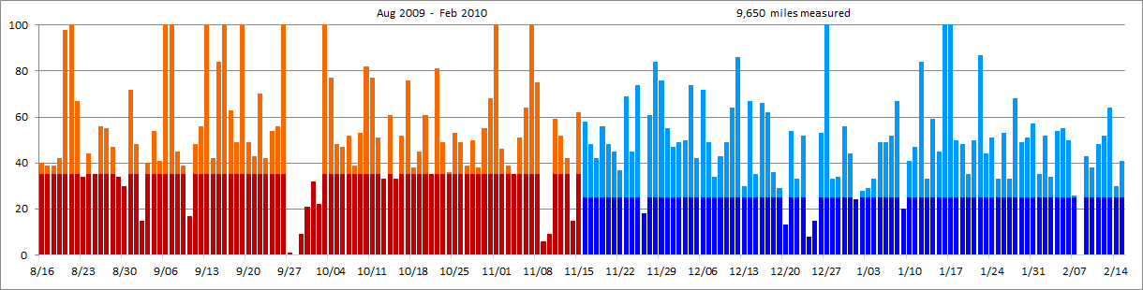
The first 6 months of data are illustrated above. The second are on the following page.
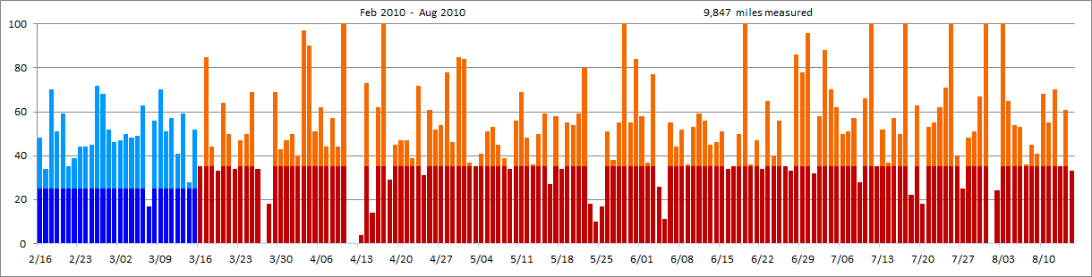
Notice the variances and how often the distance is very low or very high. The demands of life don’t allow us to follow a pattern. Clearly, there is no consistency.
Also, note that the range reduction depicted represented the impact for someone living in the north, where heater use is heavy in the winter and A/C mild in the summer.

Standardized Estimates
Many estimates are reported using a standard annual measurement of 15,000 miles. To reflect that same duration without influencing the collection of the data itself, a reduction factor is used to scale the outcome. In this report, that can be achieved by applying a factor of 0.76935 to each daily entry. That factor will proportionally reduce the 19,497 miles to represent 15,000 miles. Notice how the total distance for each daily drive has been reduced while still taking the same threshold into account.
The maximum best-case efficiency scenario for Volt in particular would be 14,600 annual miles. This is derived from multiplying the 35-mile threshold by 365 days, considering the recharge takes place each evening. That’s quite close to the standard 15,000-mile measurement, especially if you take into account a single long driving trip during the year. A more realistic scenario is one which shows greater fluctuation, since real-world doesn’t always fall nicely below a threshold. This is what the real-world data will illustrate.
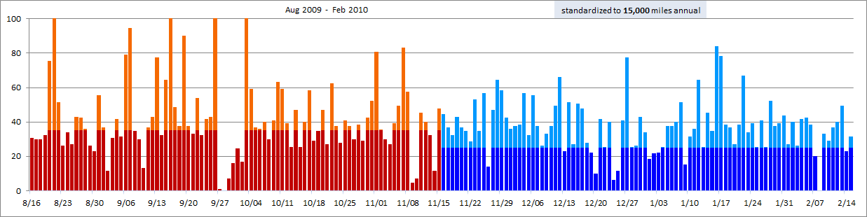
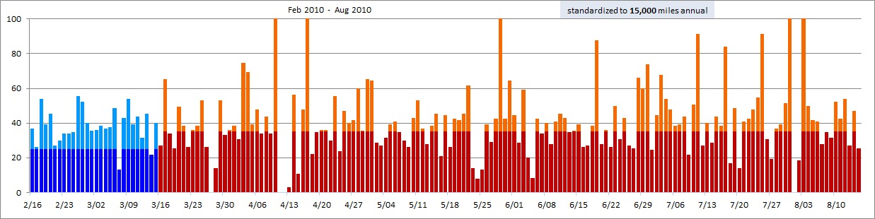

Reduced Estimates
Like the standardized approached, we want to do the same to reduce the 19,497 miles. In this case, we apply a factor of 0.6155 to each daily entry to represent 12,000 miles.
Notice how many days there are where travel still exceeds the threshold. That could be a surprise to someone who simply divides an annual total distance by 365.
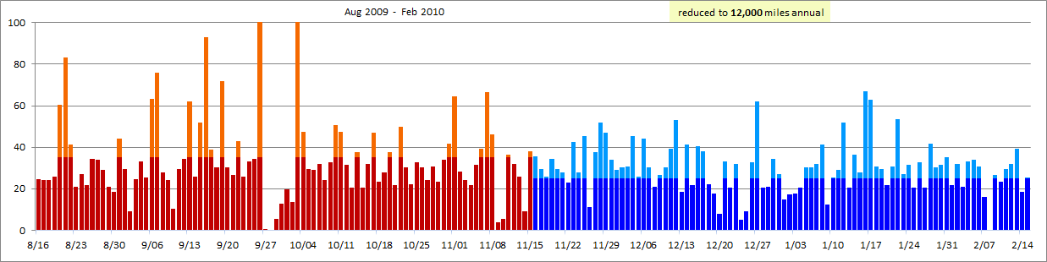
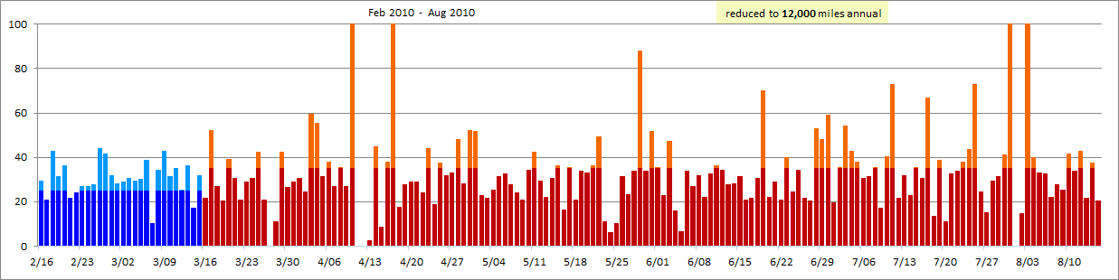

Calculations
One of the most controversial aspects of a plug-in hybrid (any type of vehicle offering both an electrical plug and fuel engine) is the measure of EV use. With a plug-in like Prius, the electricity is saved for opportunities of extreme efficiency. The engine will be used when a greater benefit can be gained from it instead. The result is an overall efficiency boost rather than a distinct time EV is delivered, a mix of propulsion methods combined. With a plug-in like Volt, it strives to use all the electricity it can prior to using the engine. That makes calculated efficiency more of just a matter of distance traveled. Those design differences affect configuration choices and resulting price, making it a challenge for consumers to compare.
Despite the complexities of efficiency measurement, it is still possible to see a basic overall outcome. Using that real-world daily-driving data collected, this an example of what the result would be based upon 15,000 miles driven annually:
gallons consumed @ 15,000 annual | MPG | Miles |  |  | Gallons
gallons consumed @ 15,000 annual | Average | EV | Hybrid | Engine | Total
Traditional vehicle | 30 | - | - | 15,000 | 500
FULL hybrid | 50 | - | 15,000 | - | 300
FULL hybrid with plug | 75 | - | 15,000 | - | 200
EREV hybrid | 35 | 10,337 | - | 4,663 | 132
EREV hybrid  (no heater, no defroster, no A/C) | 35 | 11,211 | - | 3,789 | 108
Using the same data, this an example of what the result would be based upon the entire distance measured rather than scaling it:
gallons consumed @ 19,497 annual | MPG | Miles |  |  | Gallons  2010 Prius real-world data  19,497 miles measured  390.794 gallons measured  49.9 MPG calculated
gallons consumed @ 19,497 annual | Average | EV | Hybrid | Engine | Total
Traditional vehicle | 30 | - | - | 19,497 | 500
FULL hybrid | 50 | - | 19,497 | - | 300
FULL hybrid with plug | 75 | - | 19,497 | - | 200
EREV hybrid | 35 | 10,848 | - | 8,649 | 247
EREV hybrid  (no heater, no defroster, no A/C) | 35 | 11,874 | - | 7,590 | 216
Of course, this does not take vehicle cost or financing into consideration. Efficiency alone is rarely the only purchase criteria. Other factors, such as overall emissions, are aspects of the decision as well. It also assumes vehicle seating, cargo, layout, handling, and other various specifications are fitting to the consumer.

And this is an example of what the result would be based upon 12,000 miles driven annually, considered a best-case scenario:
gallons consumed @ 12,000 annual | MPG | Miles |  |  | Gallons
gallons consumed @ 12,000 annual | Average | EV | Hybrid | Engine | Total
Traditional vehicle | 30 | - | - | 12,000 | 400
FULL hybrid | 50 | - | 12,000 | - | 240
FULL hybrid with plug | 75 | - | 12,000 | - | 160
EREV hybrid | 35 | 9,525 | - | 2,475 | 71
EREV hybrid  (no heater, no defroster, no A/C) | 35 | 10,113 | - | 1,888 | 54
Notice how many gallons per year are still consumed.
Also, note that the EREV hybrid estimates don’t include winter (no plug available) cold start-ups or take into account capacity reduction due to the cold.

Mile Counts  The hope was to identify a pattern from the daily-driving graphs. Nothing emerged though. Simple observation shows the real-world needs of most drivers are anything but routine. Running errands to the store, desire for food or entertainment, and visits to friends & family make expectations of consistency quite unrealistic.  This graph groups together mile counts, placing each individual day into a distance category. It illustrates the variety well. Predicting how many will be in each for any particular driver poses a challenge. How can they determine an expectation when so much variation is normal?  When daily-driving data reflects directly upon a battery-capacity threshold, its importance as part of a purchase decision is significant. Be careful not to over generalize. The mile counts show that could easily result in the misrepresentation of actual need. | 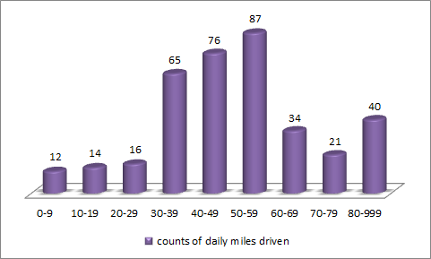
Summary
Consumer needs are quite diverse. The variety of vehicle size & type currently available express this well. This collection of daily-driving data points out how usage itself varies too, highlighting the impression of need a person may not reflect reality. It’s too easy to forget those days where driving exceeds 40 miles or how long you got stuck in heavy traffic with the heater running.
The FULL hybrids have already demonstrated that a wide variety of configurations can be offered, along with the choice of a plug and battery-pack capacity. The EREV hybrid will initially only be offered with a plug and only with a single capacity. For those whose needs that actually fit, they may be able to take advantage of the opportunity. For those whose needs do not, what will they purchase? How much are they willing to spend? Are they aware of how much gas will still be consumed even when plugging in?
“Gallons Consumed” is the ultimate measure of engine efficiency. It’s really unfortunate that the United States depends upon MPG as a basis of comparison. Most of the world uses a Distance-Per-Unit system instead, often expressed as “100 km/l”. That’s the quantity (in liters) of fuel required to travel 100 kilometers. They system doesn’t disregard actual impact based on distance as MPG does. It’s an excellent example of how typical consumers are easily misled and make assumptions about vehicle efficiency, a deceptive practice called “greenwashing” when intentional. Fortunately, the EPA has acknowledged this problem and recently began providing Distance-Per-Unit values too.
Finally, keep in mind that not all electricity is equal. Some comes from clean & renewable sources. Others are still quite harmful to the environment.

Odometer Data

8/15 5,508
8/16 5,548
8/17 5,587
8/18 5,626
8/19 5,668
8/20 5,766
8/21 5,901
8/22 5,968
8/23 6,002
8/24 6,046
8/25 6,081
8/26 6,137
8/27 6,192
8/28 6,239
8/29 6,273
8/30 6,303
8/31 6,375
9/1 6,423
9/2 6,438
9/3 6,478
9/4 6,532
9/5 6,573
9/6 6,676
9/7 6,799
9/8 6,844
9/9 6,883
9/10 6,900
9/11 6,948
9/12 7,004
9/13 7,105
9/14 7,147
9/15 7,231
9/16 7,382
9/17 7,445
9/18 7,494
9/19 7,611
9/20 7,660
9/21 7,703
9/22 7,773
9/23 7,815
9/24 7,869
9/25 7,925
9/26 8,132
9/27 8,133
9/28 8,133
9/29 8,142
9/30 8,163
10/1 8,195
10/2 8,217
10/3 8,414
10/4 8,491
10/5 8,539
10/6 8,586
10/7 8,638
10/8 8,677
10/9 8,730
10/10 8,812
10/11 8,889
10/12 8,940
10/13 8,973
10/14 9,034
10/15 9,067
10/16 9,119
10/17 9,195
10/18 9,233
10/19 9,278
10/20 9,339
10/21 9,374
10/22 9,455
10/23 9,504
10/24 9,540
10/25 9,593
10/26 9,642
10/27 9,681
10/28 9,731
10/29 9,769
10/30 9,824
10/31 9,892
11/1 9,997
11/2 10,043
11/3 10,082
11/4 10,117
11/5 10,168
11/6 10,232
11/7 10,340
11/8 10,415
11/9 10,421
11/10 10,430
11/11 10,489
11/12 10,541
11/13 10,583
11/14 10,598
11/15 10,660
11/16 10,718
11/17 10,766
11/18 10,808
11/19 10,864
11/20 10,912
11/21 10,957
11/22 10,994
11/23 11,063
11/24 11,108
11/25 11,182
11/26 11,200
11/27 11,261
11/28 11,345
11/29 11,421
11/30 11,476
12/1 11,523
12/2 11,572
12/3 11,622
12/4 11,696
12/5 11,738
12/6 11,810
12/7 11,859
12/8 11,893
12/9 11,936
12/10 11,985
12/11 12,049
12/12 12,135
12/13 12,165
12/14 12,232
12/15 12,267
12/16 12,333
12/17 12,395
12/18 12,431
12/19 12,460
12/20 12,473
12/21 12,527
12/22 12,560
12/23 12,612
12/24 12,620
12/25 12,635
12/26 12,688
12/27 12,789
12/28 12,822
12/29 12,856
12/30 12,912
12/31 12,956
1/1 12,980
1/2 13,008
1/3 13,037
1/4 13,070
1/5 13,119
1/6 13,168
1/7 13,220
1/8 13,287
1/9 13,307
1/10 13,348
1/11 13,395
1/12 13,479
1/13 13,512
1/14 13,571
1/15 13,616
1/16 13,725
1/17 13,827
1/18 13,877
1/19 13,925
1/20 13,960
1/21 14,010
1/22 14,097
1/23 14,141
1/24 14,192
1/25 14,225
1/26 14,278
1/27 14,311
1/28 14,379
1/29 14,428
1/30 14,479
1/31 14,536
2/1 14,571
2/2 14,623
2/3 14,657
2/4 14,711
2/5 14,766
2/6 14,816
2/7 14,842
2/8 14,842
2/9 14,885
2/10 14,923
2/11 14,971
2/12 15,023
2/13 15,087
2/14 15,117
2/15 15,158
2/16 15,206
2/17 15,240
2/18 15,310
2/19 15,361
2/20 15,420
2/21 15,455
2/22 15,494
2/23 15,538
2/24 15,582
2/25 15,627
2/26 15,699
2/27 15,767
2/28 15,819
3/1 15,865
3/2 15,912
3/3 15,962
3/4 16,010
3/5 16,059
3/6 16,122
3/7 16,139
3/8 16,195
3/9 16,265
3/10 16,316
3/11 16,373
3/12 16,414
3/13 16,473
3/14 16,501
3/15 16,553
3/16 16,588
3/17 16,673
3/18 16,717
3/19 16,750
3/20 16,814
3/21 16,864
3/22 16,898
3/23 16,945
3/24 16,995
3/25 17,064
3/26 17,098
3/27 17,098
3/28 17,116
3/29 17,185
3/30 17,228
3/31 17,275
4/1 17,325
4/2 17,365
4/3 17,462
4/4 17,552
4/5 17,603
4/6 17,665
4/7 17,709
4/8 17,766
4/9 17,810
4/10 18,001
4/11 18,001
4/12 18,001
4/13 18,005
4/14 18,078
4/15 18,092
4/16 18,154
4/17 18,388
4/18 18,417
4/19 18,462
4/20 18,509
4/21 18,556
4/22 18,595
4/23 18,667
4/24 18,698
4/25 18,759
4/26 18,811
4/27 18,865
4/28 18,943
4/29 18,989
4/30 19,074
5/1 19,158
5/2 19,195
5/3 19,230
5/4 19,271
5/5 19,322
5/6 19,375
5/7 19,420
5/8 19,459
5/9 19,493
5/10 19,549
5/11 19,618
5/12 19,666
5/13 19,702
5/14 19,752
5/15 19,811
5/16 19,838
5/17 19,896
5/18 19,930
5/19 19,985
5/20 20,039
5/21 20,098
5/22 20,178
5/23 20,196
5/24 20,206
5/25 20,223
5/26 20,274
5/27 20,312
5/28 20,367
5/29 20,510
5/30 20,565
5/31 20,649
6/1 20,707
6/2 20,744
6/3 20,821
6/4 20,847
6/5 20,858
6/6 20,913
6/7 20,957
6/8 21,009
6/9 21,045
6/10 21,098
6/11 21,157
6/12 21,213
6/13 21,258
6/14 21,304
6/15 21,355
6/16 21,389
6/17 21,424
6/18 21,474
6/19 21,588
6/20 21,624
6/21 21,671
6/22 21,705
6/23 21,770
6/24 21,810
6/25 21,866
6/26 21,901
6/27 21,934
6/28 22,020
6/29 22,098
6/30 22,194
7/1 22,226
7/2 22,284
7/3 22,372
7/4 22,442
7/5 22,504
7/6 22,554
7/7 22,605
7/8 22,662
7/9 22,690
7/10 22,756
7/11 22,875
7/12 22,910
7/13 22,962
7/14 22,999
7/15 23,056
7/16 23,106
7/17 23,215
7/18 23,237
7/19 23,300
7/20 23,318
7/21 23,371
7/22 23,426
7/23 23,488
7/24 23,559
7/25 23,678
7/26 23,718
7/27 23,743
7/28 23,791
7/29 23,842
7/30 23,909
7/31 24,140
8/1 24,140
8/2 24,164
8/3 24,389
8/4 24,454
8/5 24,508
8/6 24,561
8/7 24,597
8/8 24,642
8/9 24,683
8/10 24,751
8/11 24,806
8/12 24,876
8/13 24,911
8/14 24,972
8/15 25,005

