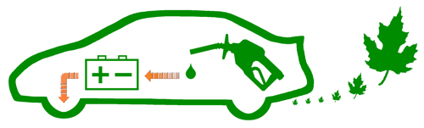
Prius Owner Summary

It has been a fantastic ownership experience, enjoyable on many levels.
I recommend trying the same for anyone wanting to significantly reduce emissions & consumption.

The price paid for my well loaded 2004 Prius (Pioneer #3 model) was: $25,939.00 (plus $1,736.06 tax & fee)
This is a summary of my expenses as of the following distance traveled: 107,163 miles
 | Quantity | Expense
Fuel gallons | 2,233.906 | $5,369.62
Oil & Filter replacements | 19 | $439.07
Comprehensive services | 3 | $521.82
Intermediate services | 3 | $454.91  trade-in estimate from Kelly Blue Book  condition: Good miles: 120,000  $9,450.00  * Oct. 2008 estimate from Edmunds “True Cost to Own”  Tires expected to last until odometer reading: 165,000
Tire replacements (full sets) | 2 | $984.41
Tire services | 8 | $319.83
Misc routine | 7 | $287.06
Misc unexpected | 5 | $402.83
Insurance * | 5 | $6,355.00
Total Expenses |  | $15,134.55

This graph shows the price I’ve paid for gas over the years, dating back to the purchase of my 2001 Prius:
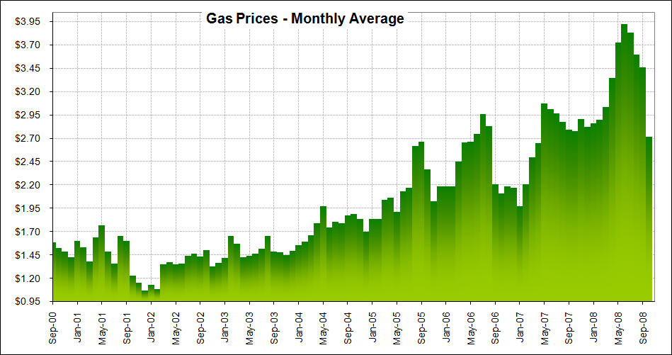
My calculated Lifetime Average is: 48.0 MPG

Living in Minnesota, it has been especially informative keeping track of my real-world data. Driving results will change significantly, just like the seasons. Winter is the most demanding, since heat is needed to keep both me and the emission system warm. That requires using the engine more often.
The following summarizes details from my spreadsheets, grouping months with similar climate characteristics together to illustrate changes during the annual cycle:
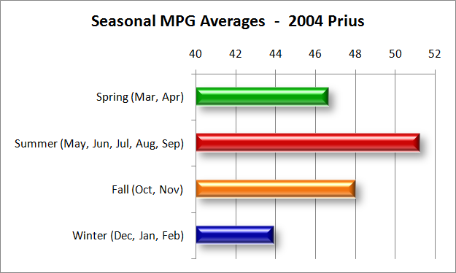

Here is another way to see those annual cycle fluctuations; notice how much the MPG monthly averages vary:
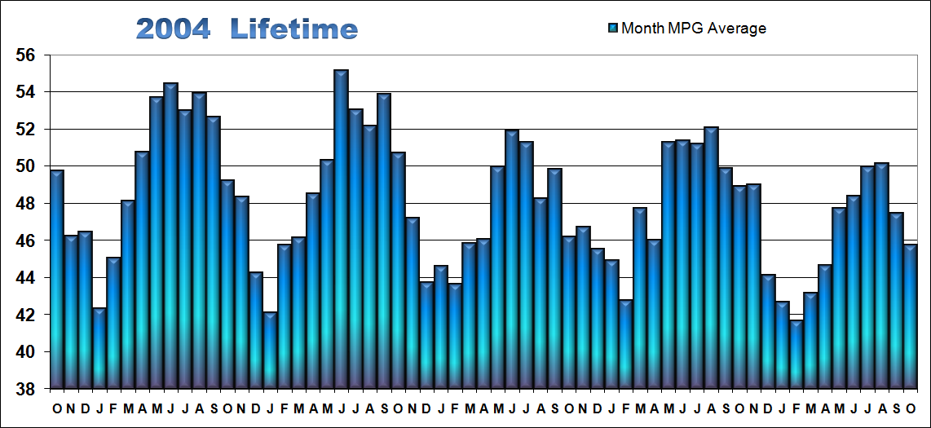

To see my spreadsheets along with more graphs, go to the website… http://john1701a.com
Summer recreation includes carrying kayaks on the roof a few times. Trips up north with two on top really drag down efficiency. But that’s well worth it. And even then, at its worse (70 MPH on the highway) the drop was only to 36 MPG. Some vehicles can’t get that at their best! So, I didn’t mind.
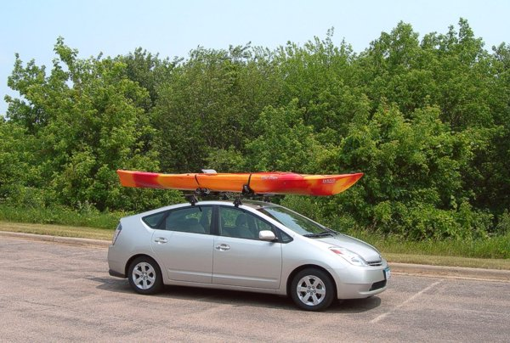

Added safety from switching to high-traction all-season (Michelin HydroEdge) tires was worth a MPG reduction too.
Use of E10 (gas blended with 10% ethanol) has been mandated for over a decade here in Minnesota. Supporting it for cleaner emissions and continued improvement make the MPG reduction a meaningful long-term benefit.
None of that spoils any of my fun. This is a photo of my Prius at the same park, during a really cold winter:
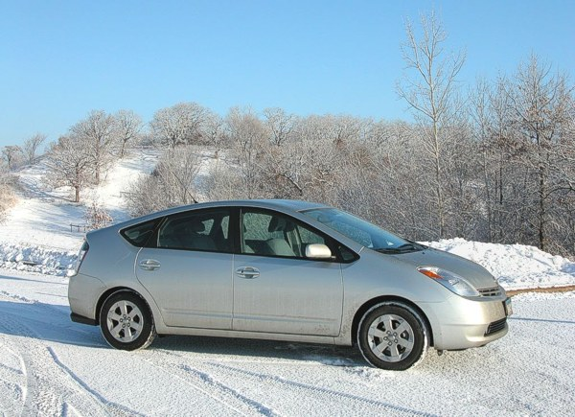

I’m pretty darn happy. Prius has proven a great choice, a hybrid that really delivers. What else do you need to know?

