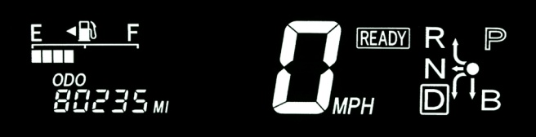

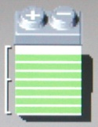
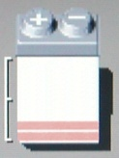
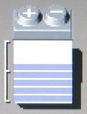
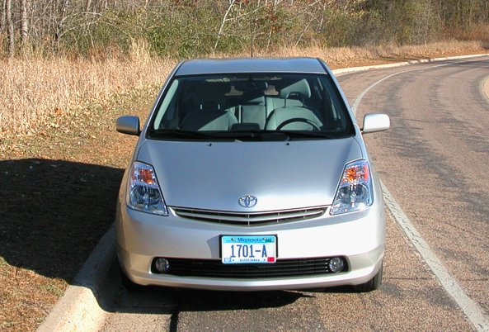
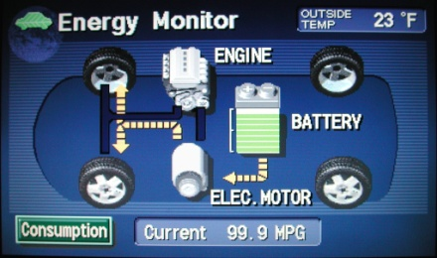
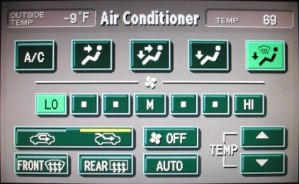
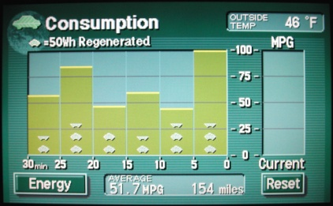
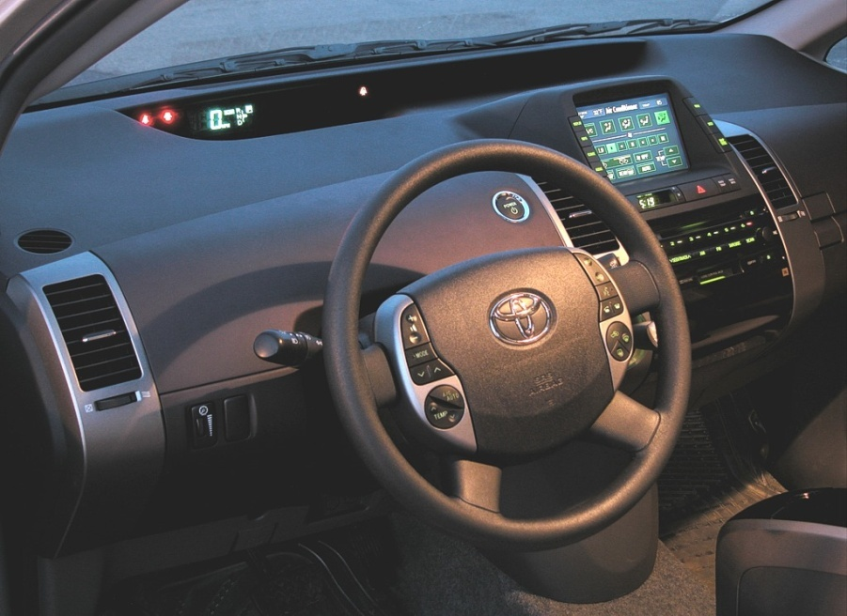
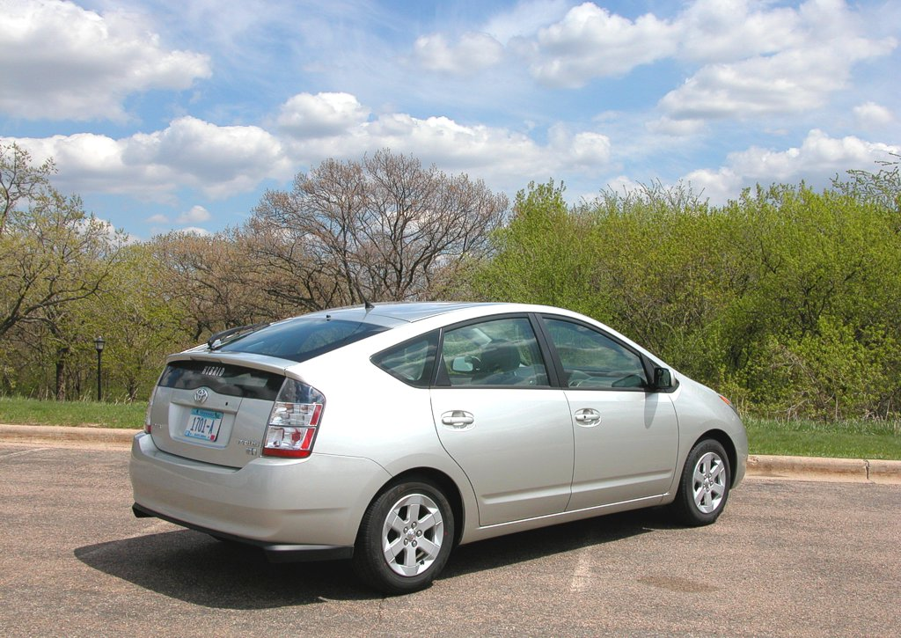

Prius Owner Data & Photos: http://john1701a.com

Online Discussion Forum: http://priuschat.com

Information from Toyota: http://www.toyota.com/prius
Battery-Pack
Charge-Level

Indicator
Just Drive It. Ignore all the technology. Let the computer worry about how to save gas and achieve the AT-PZEV emission rating

for you. Enjoy the remarkably smooth & quiet ride.
CD & Cassette Players
Multi-Display Screen
Power (Startup) Button
Speedometer & More
Stereo & Climate Controls
Park, Reverse, Drive Shift
Emissions: | AT-PZEV  (Advanced Technology - Partial Zero Emission Vehicle)  90% less NO_{X} (Nitrogen Oxides) than average  50% less CO₂ (Carbon Dioxide) than average
MPG: | EPA rating: 60 City, 51 Highway, 55 Combined  YMMV (Your Mileage May Vary)

