2010 Prius - Driving Modes

Purpose:
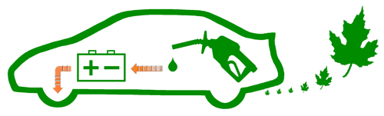
Having a variety of modes to choose from allows the driver to adjust the dynamics of the vehicle, such as pedal responsiveness and air-conditioning restraint. This flexibility provides the option to favor different aspects of performance during the driving experience.

Types:
Automatic | This mode type will automatically engage when the proper conditions are met. Pressing a button is not necessary and there is no indicator.
Manual | This mode type requires the driver to explicitly select it. The choice will then be indicated with an illuminated symbol by the speedometer.

Choices:
Normal | - Automatic  - Regular driving
Stealth | - Automatic (warm emission-system always required)  - Electric-Only with the Engine stopped (zero RPM)  - Maximum speed of 45 MPH  - Regular driving
EV | - Manual (warm emission-system sometimes required)  - Electric-Only with the Engine stopped (zero RPM)  - Maximum speed of 25 MPH  - Intended for uses when starting the engine is not necessary, such as pulling the car out of the garage, moving along in heavy stop & slow traffic, and waiting in line at the drive-thru
ECO | - Manual  - Pedal sensitivity range increased, to favor modest acceleration  - A/C maximum electrical draw is reduced  - Efficiency driving
PWR | - Manual  - Pedal sensitivity range decreased, to favor assertive acceleration  - High-Demand driving
Last Updated: 7/31/2009

