


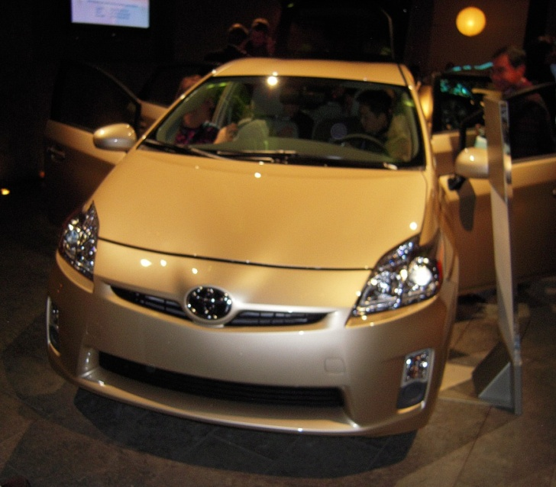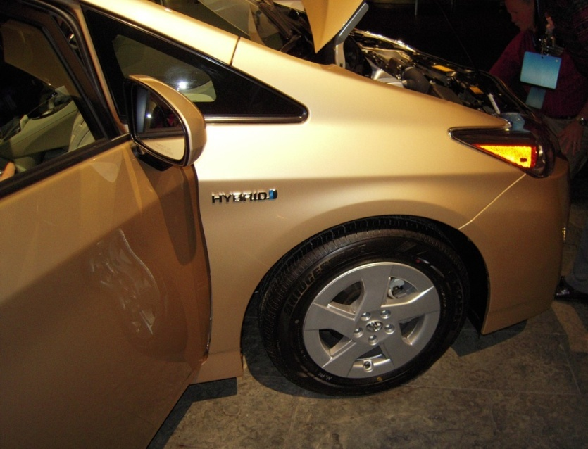


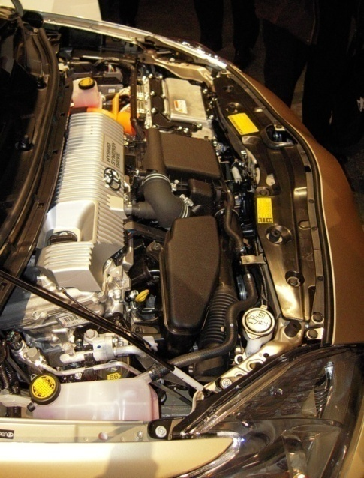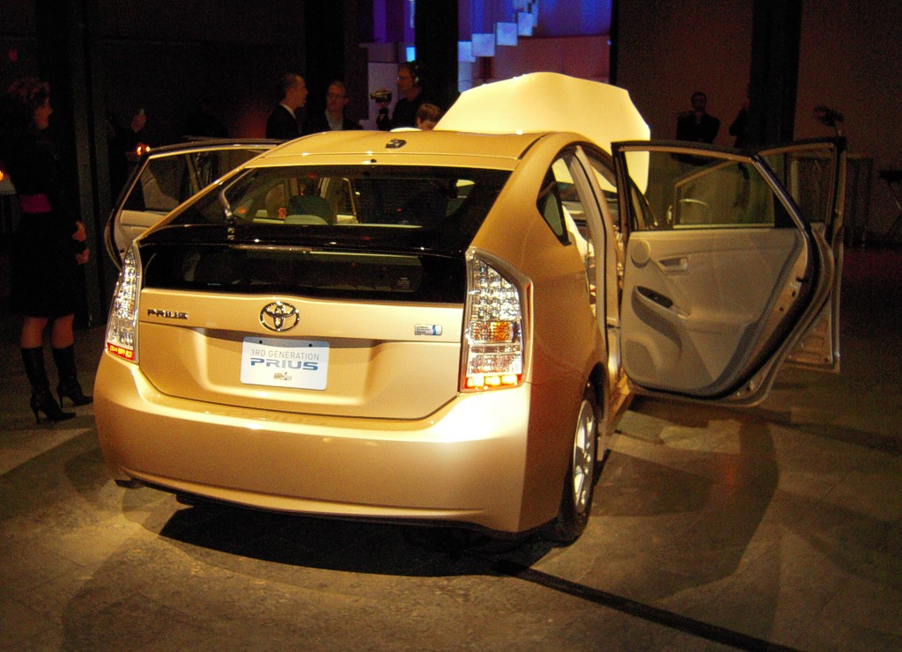

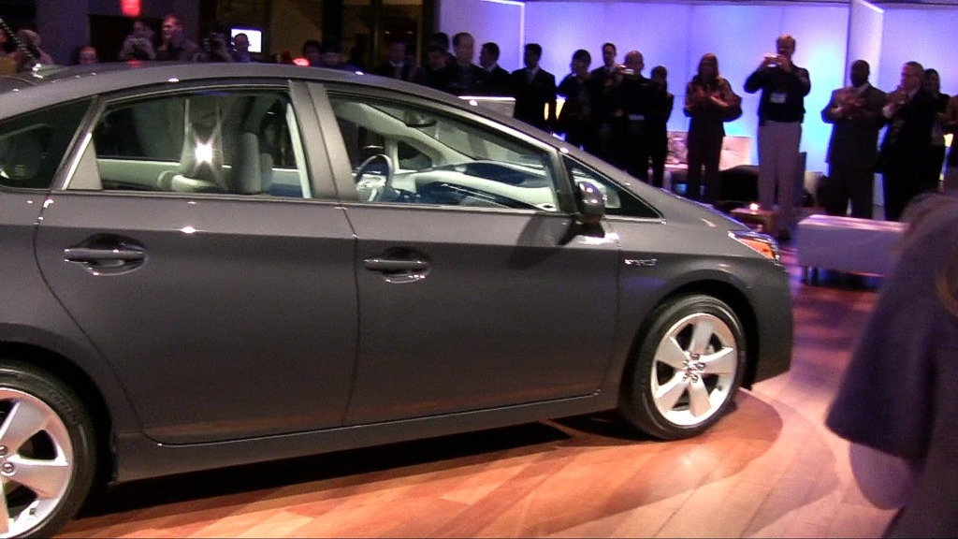


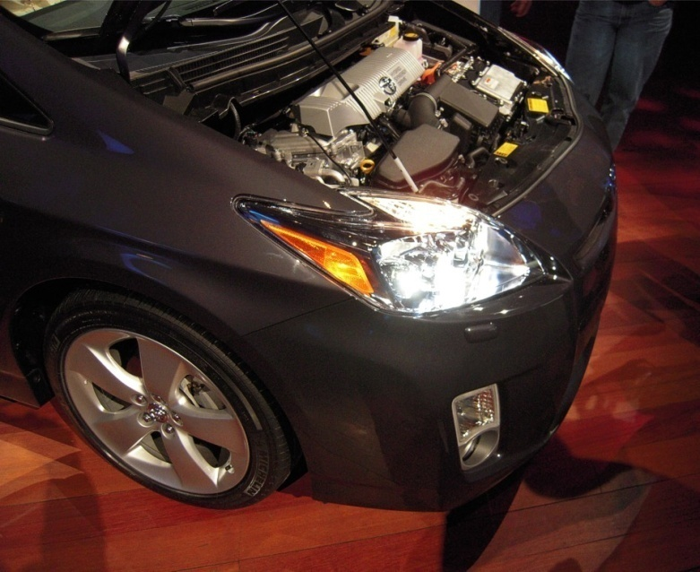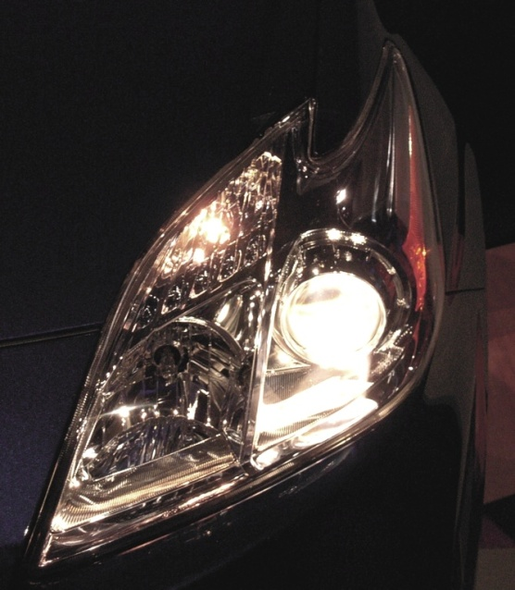

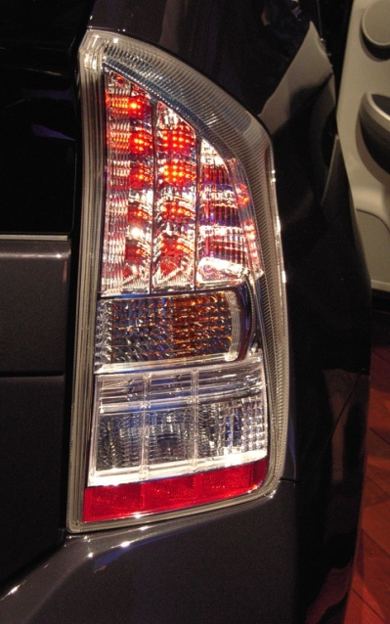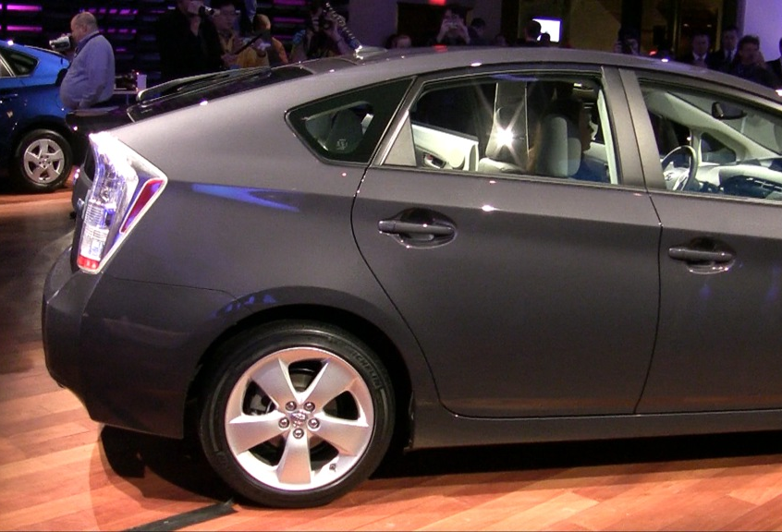

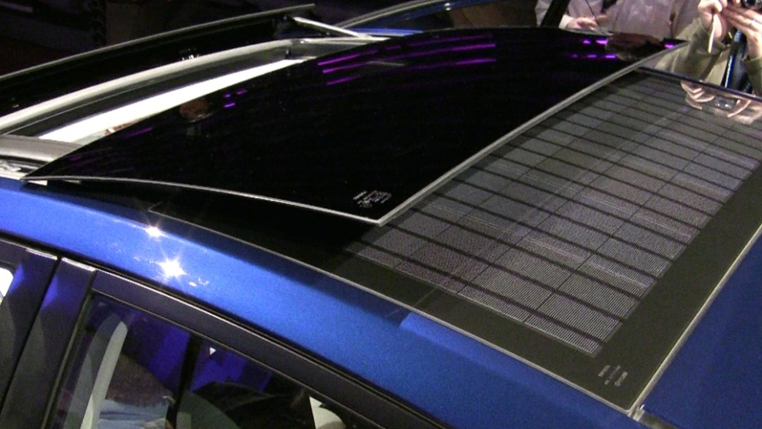
Among the new options available with the 2010 model, there’s a solar panel. This is used to power the cabin blower to keep the interior cool while the car is parked.

Another new option is the moonroof. It can both tip upward and slide back.

Notice the difference in these two interiors. Up by the Speedometer is where the Energy-Monitor & Consumption-Screen have moved to, presented on the new standard Info-Display. As an option, you can also get a Multi-Display for use with navigation, phone, music, and backup video.

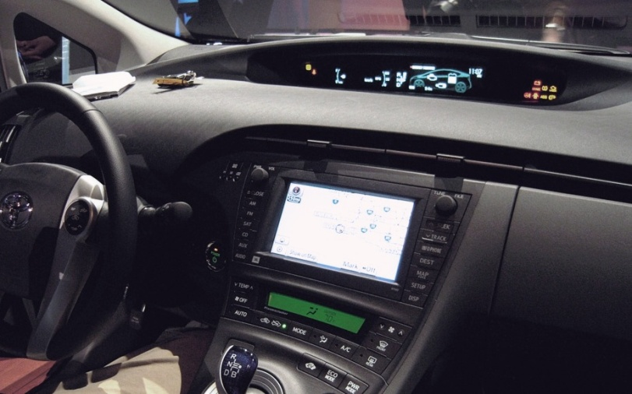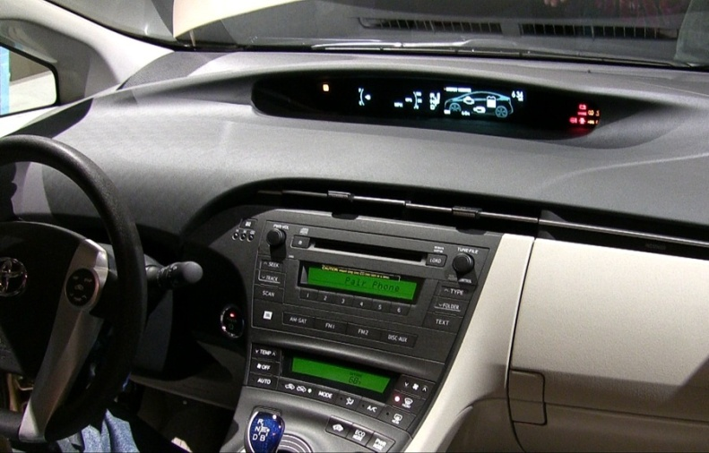

EV (Electric-Vehicle), ECO (Economy), and PWR (Power) mode buttons are now available.

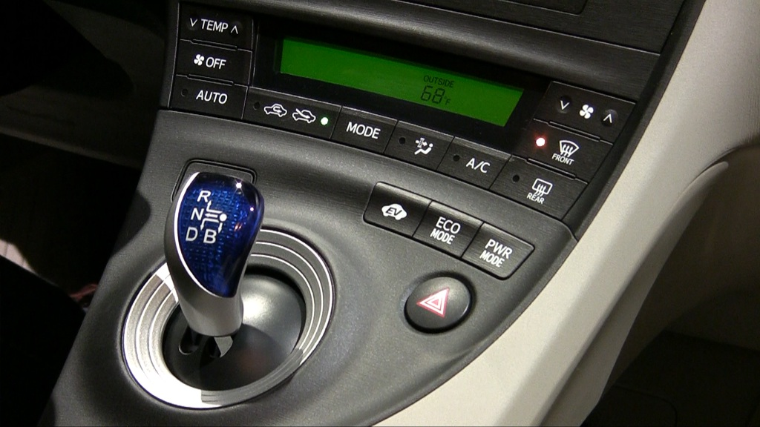

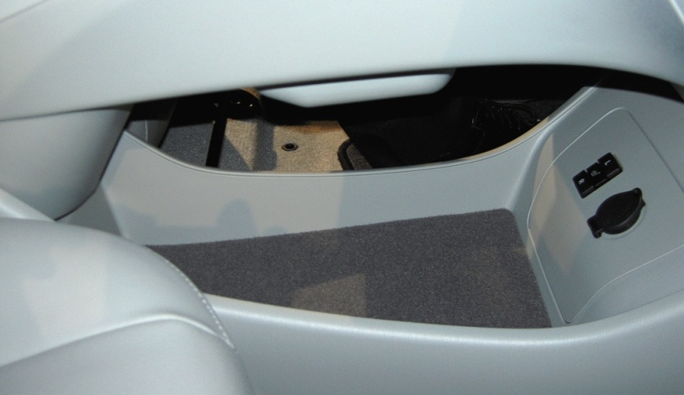
Underneath the gear-selector and mode buttons is a large storage area, along with a 12-volt power outlet and switches for the heated-seat option.

This is a convenient location to place a purse or a box of tissues.

This is the new Energy-Monitor on the new Info-Display. It provides information about vehicle energy, indicating power flow from the gas engine, the electric motor, and the battery-pack. There’s also a clock and odometer.

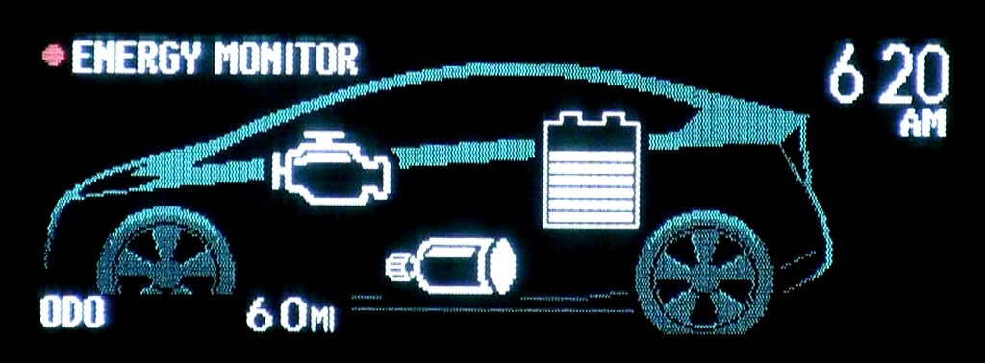

This is the new Consumption-Screen on the new Info-Display. It provides efficiency information about the most 30 minutes of driving. There’s also a fuel-indicator for, showing a distance-to-empty value.

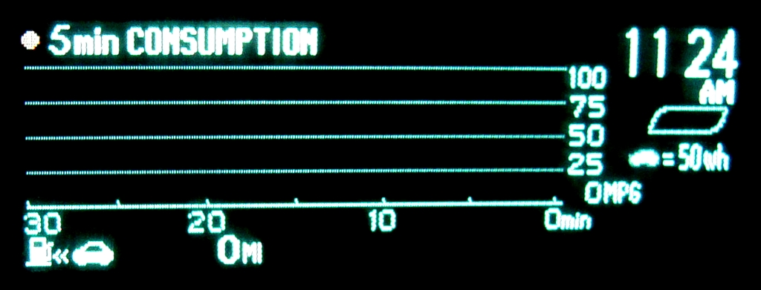

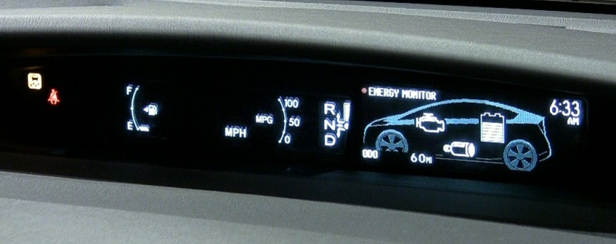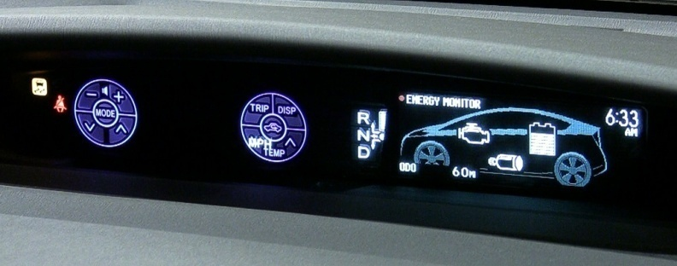

Touch-Tracer is a new feature introduced with the 2010 model Prius. When you press a button on the steering-wheel, the Fuel & MPG gauges on each side of the Speedometer are hidden. In their place, you’ll see those buttons are displayed by the visual interface with the one currently being touched indicated with an orange background. (Notice the change above and the outcome below.)

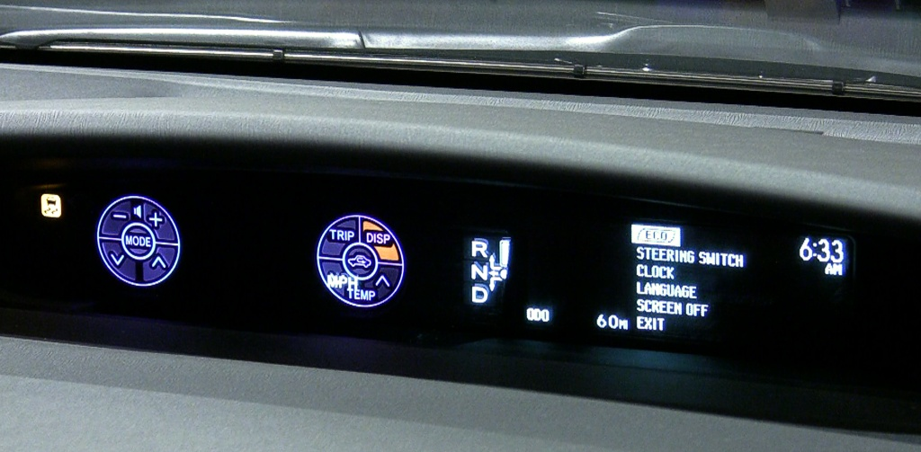

On right above, the display menu is shown. Below are examples of some choices available, including an Eco-Meter, a Consumption screen, and Past-Record for trips.

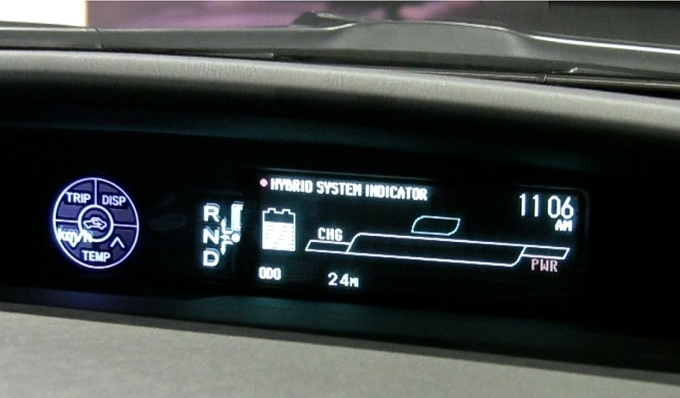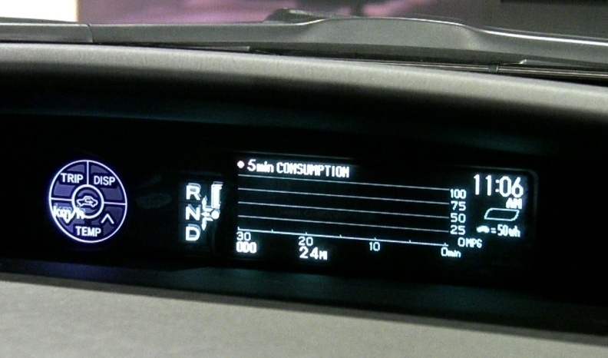

Document Revision: 2-09-2009

