Port & Reader
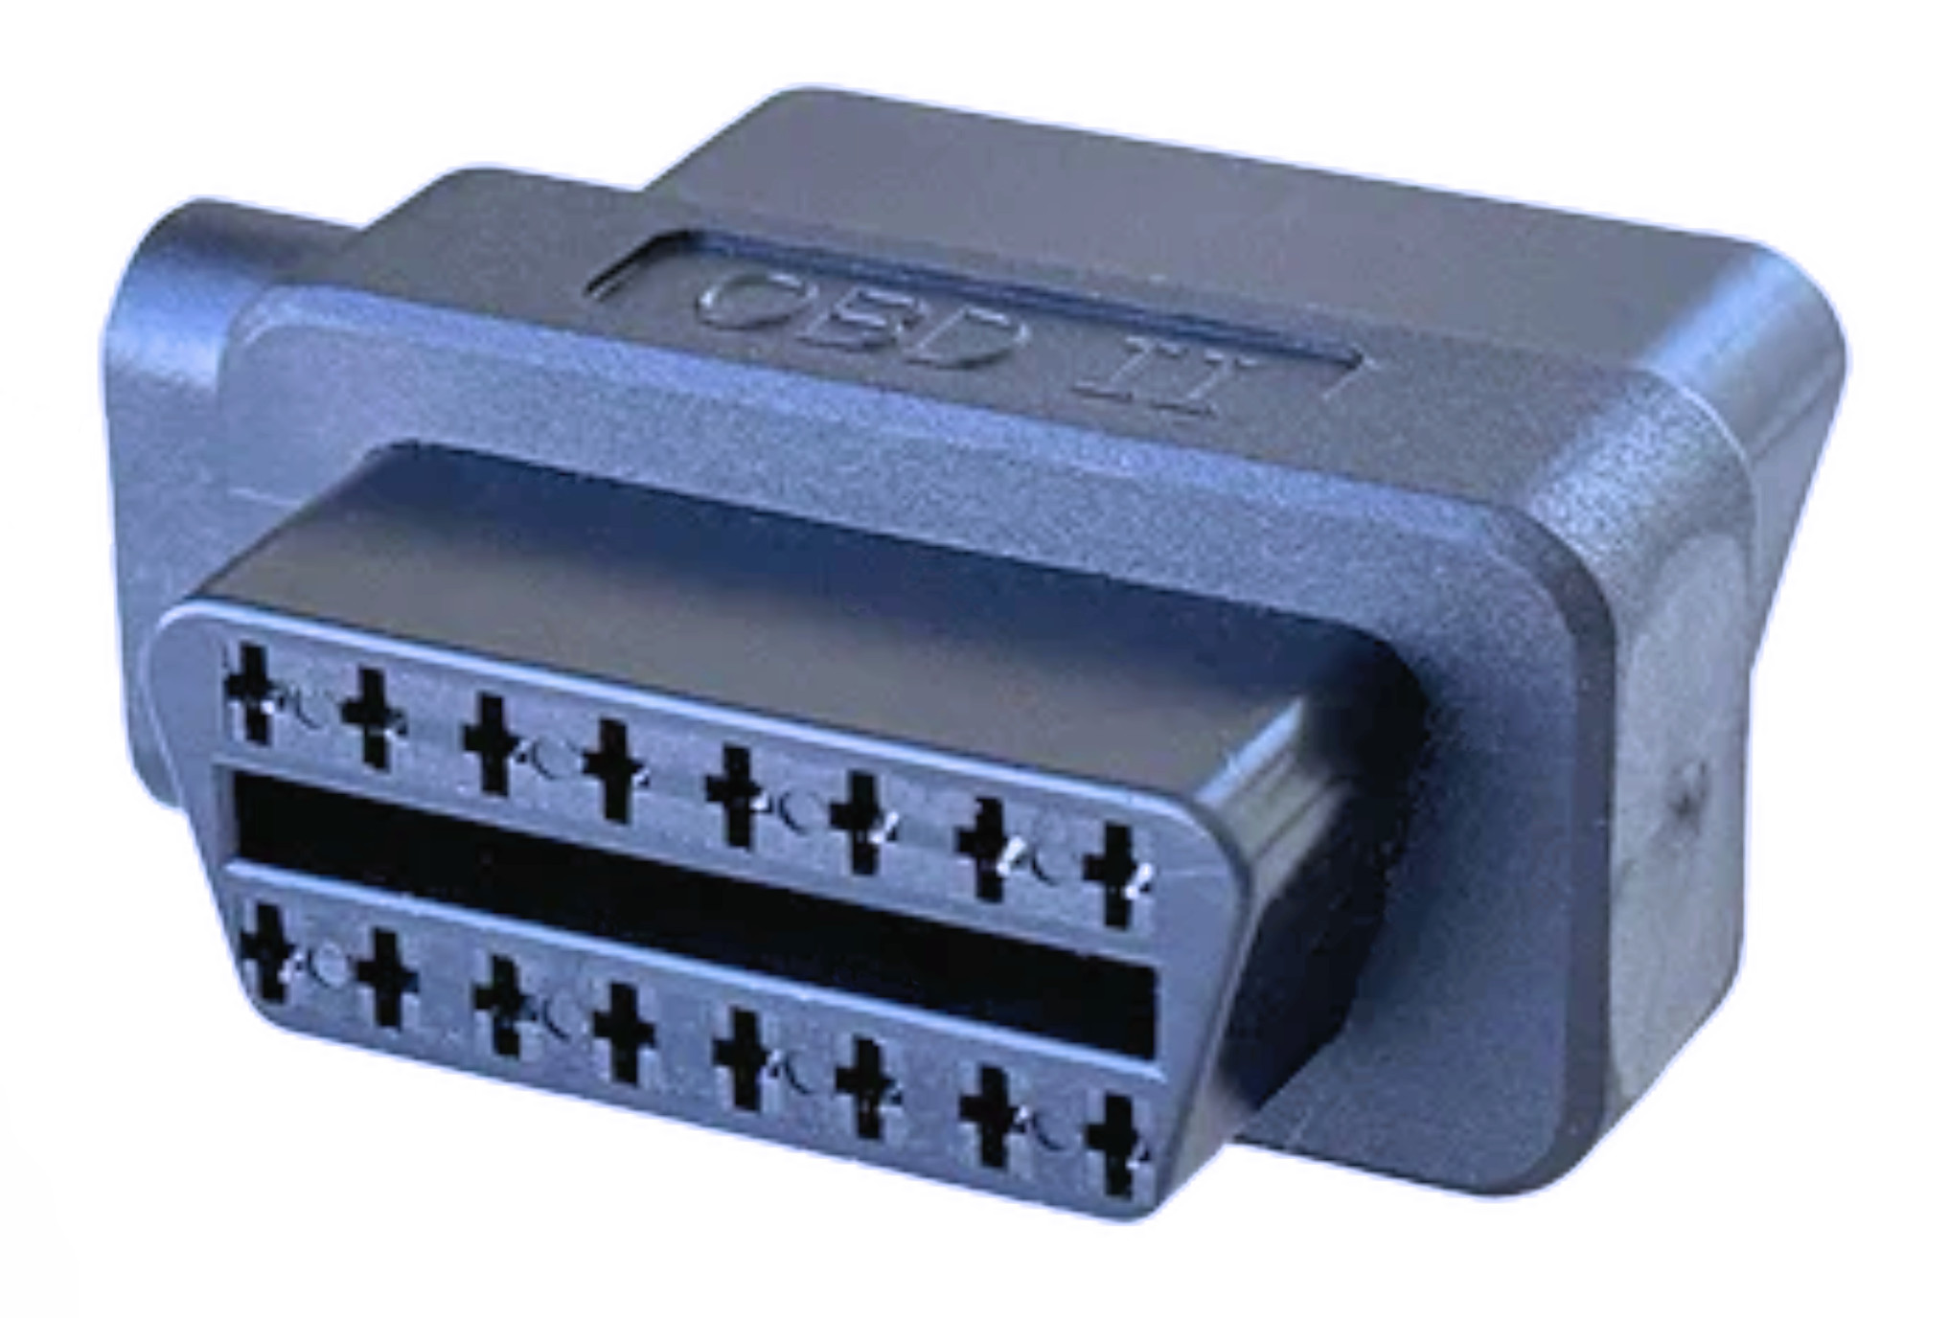 | 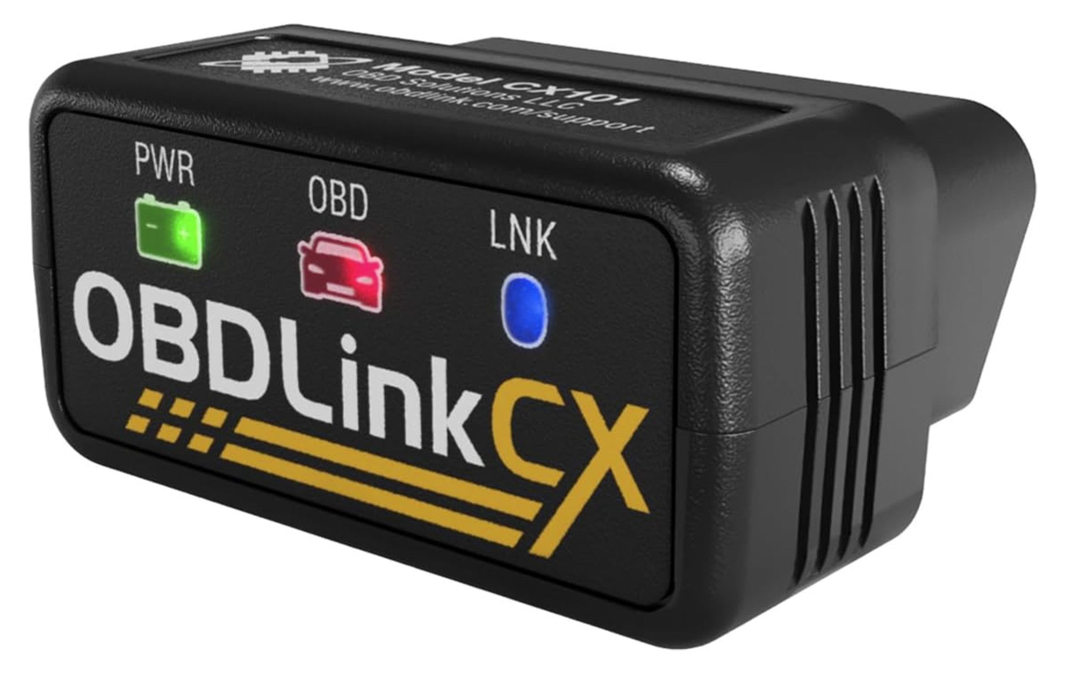 | The first image is the OBD-II port, a handy connection that enables the ability to access vehicle data ordinarily hidden from drivers. It’s located under the dashboard.  The second image is example of an OBD-II reader, a device that wirelessly transmits vehicle data from the OBD-II port. This is an aftermarket purchase.
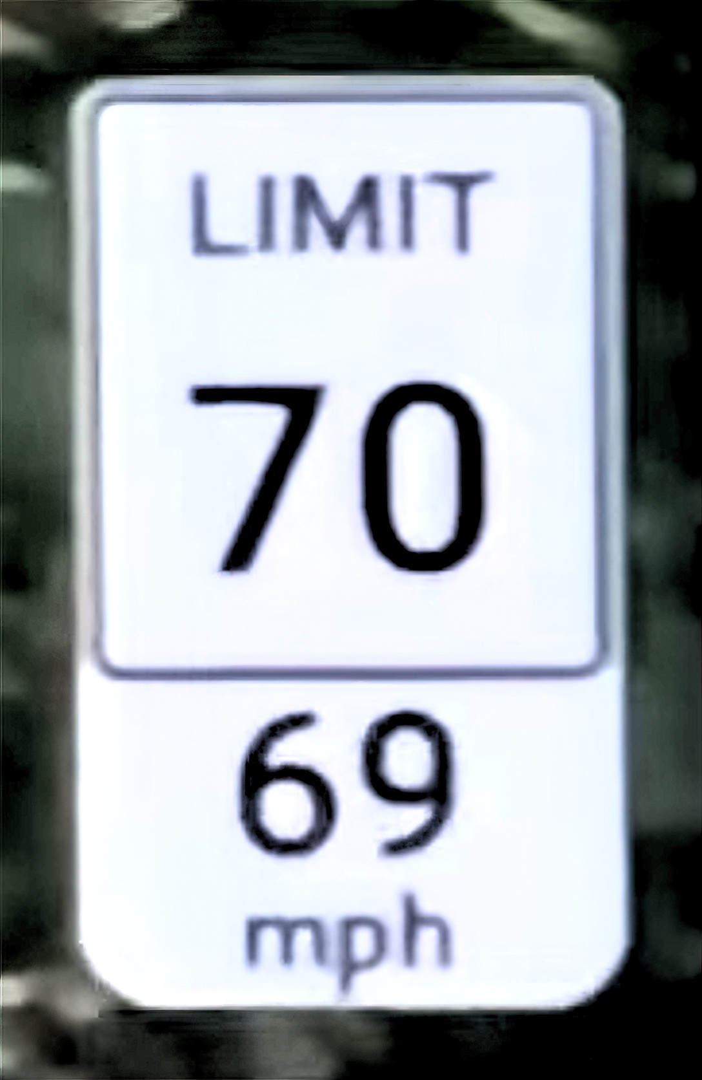
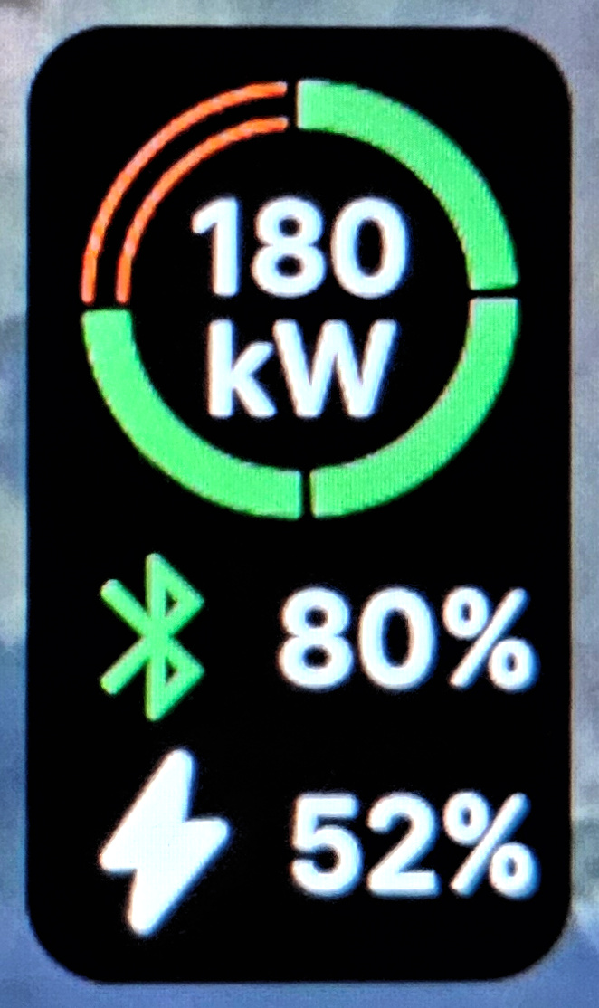
App Integration
The most basic benefit is allowing your Apple CarPlay or Android Auto app to have access to vehicle data. That integration provides data such as current battery state-of-charge and driving speed.
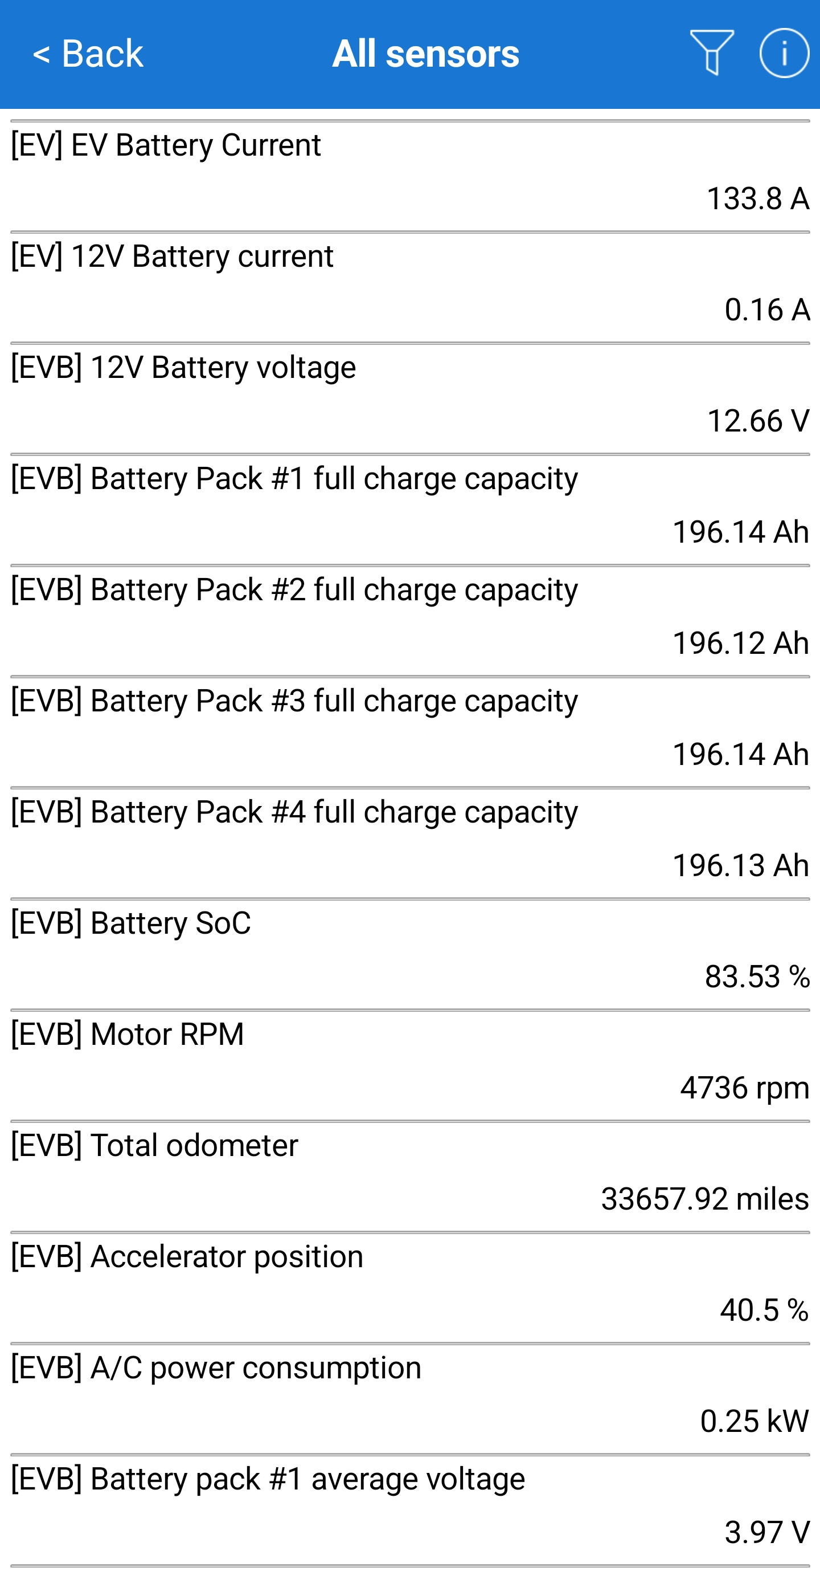
Hidden Detail
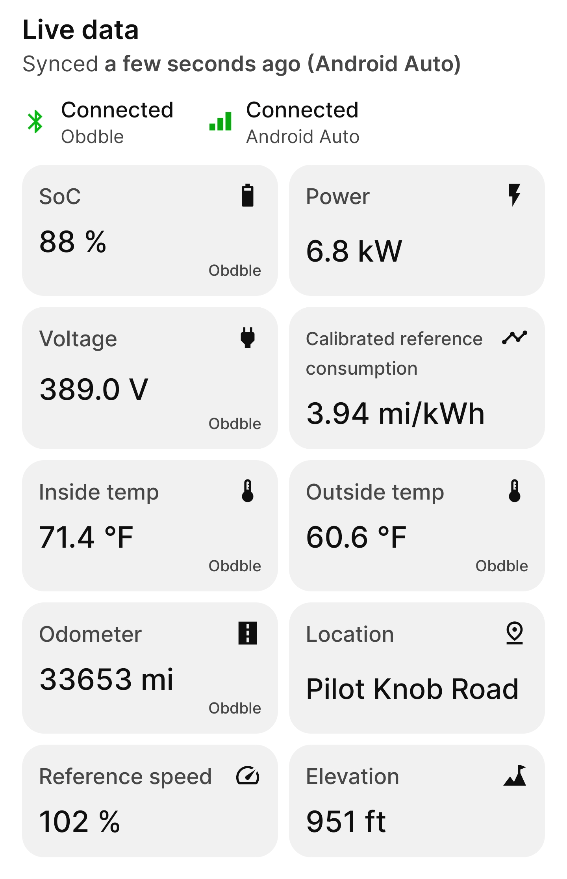 | Some apps, like ABRP (A Better Routeplanner), provide an interface to display live data. Seeing detail not provided on the vehicle’s dashboard can be quite informative.  Other apps, like “Car Scanner Pro”, allow access to all sensors visible with OBD-II. From that, you can create customized displays to see diagnostic detail.  For an EV, checking Ah (amp-hour) is how you determine battery health. That value drops as the battery ages.

Custom Gauges
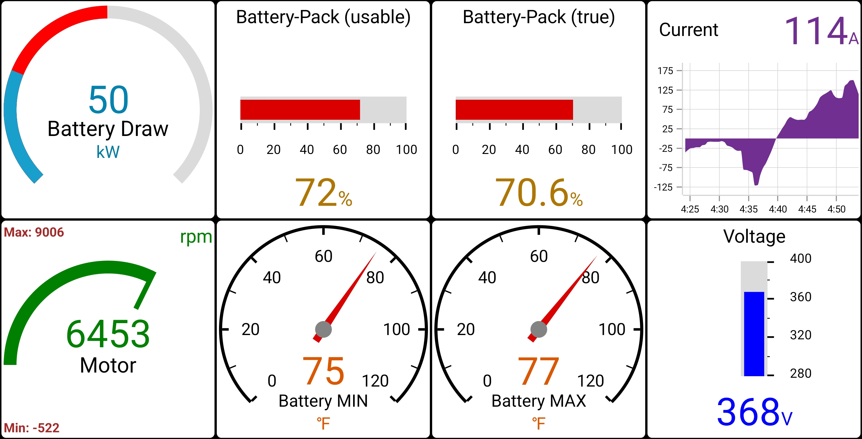 | When you have access to all sensors, that app will typically offer the option to create a collection of custom gauges to display.  For an example of this, scan the following to view an EV driving video.
 |  | 

