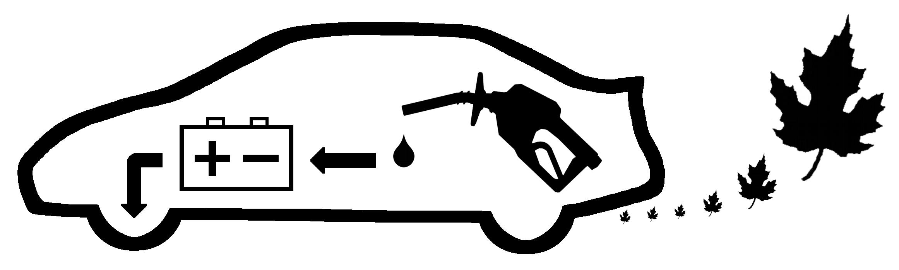

Got Voltage !

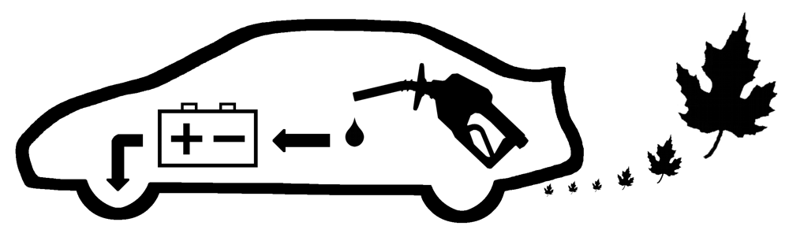  Super Ultra Low Emission - Hybrid Electric |  | Super Ultra Low Emission - Hybrid Electric

