Home Charging

Prius Prime

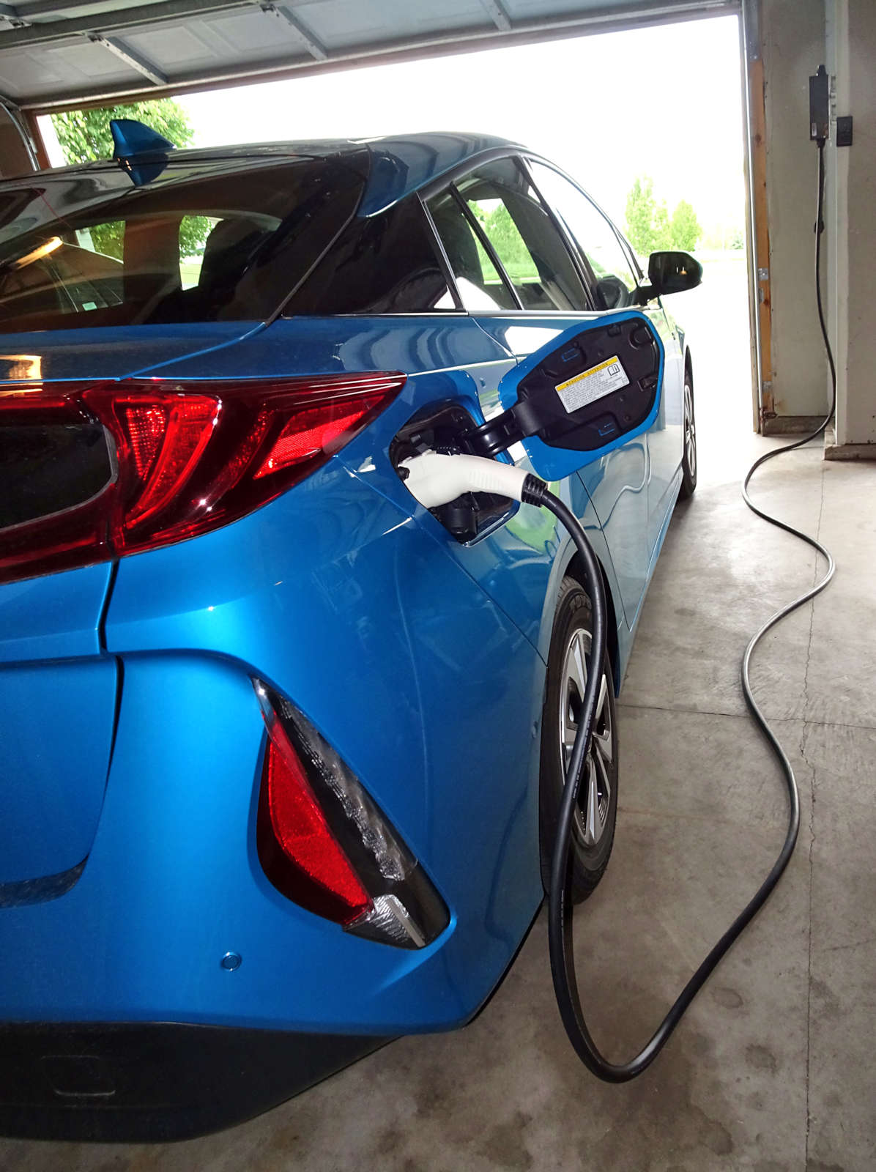 | 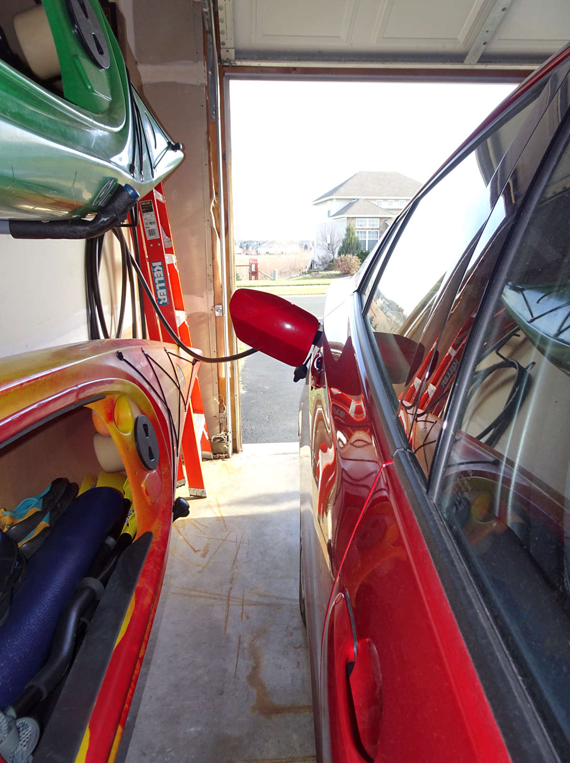

25 miles of EV (Electric Vehicle) driving is available per charge from Prius Prime. When that plug-supplied electricity is used up, the system automatically switches to HV (Hybrid Vehicle) driving.

5 hours and 30 minutes is how long it takes to recharge the battery when plugging into a 120-volt standard household outlet using the charger included with the purchase of Prius Prime.

2 hours and 10 minutes is what the recharge time can be reduced to by upgrading to a faster charger and connecting to a dedicated 240-volt outlet. Upgrading is not complicated; however, there are several important things to consider before making that decision.

Results will vary. It's very important to keep this mind. EV distance can be reduced or increased depending upon driving conditions. Recharge time can be reduced or increased depending upon the equipment, connection, and temperature.

Charging Basics

Time available for recharging makes a big difference. Overnight provides ample opportunity for slow recharging. If that's all you need, there would be little benefit from upgrading. If you will be recharging sometimes during the day for immediate use, having high-speed available would be advantageous.

Choices are plentiful. Consider many important aspects before making a decision. Do you wish to only make your Prime recharging faster or do you want to install equipment capable of even faster recharging of a future vehicle later? Will you be installing another charger at some point so a second vehicle could also be recharged at the same time? Is there a need to monitor or control the charger from your computer or phone?

Discounts from your electricity provider may be available. If you wish to take advantage of that cost saving opportunity, adding a sub-meter to your existing service-panel or running a new secondary line to your home will be necessary. Since both discounts and physical requirements will vary significantly for each homeowner, carefully research options before making a purchase or signing a contract.

Pre-Condition is the ability for Prime to cool or warm the passenger area prior to departure using only electricity, while still plugged in. With a 240-volt connection, there is minimal impact to recharge time. The system will draw as much electricity as possible directly from the plug, rather than using the battery for interior temperature comfort.

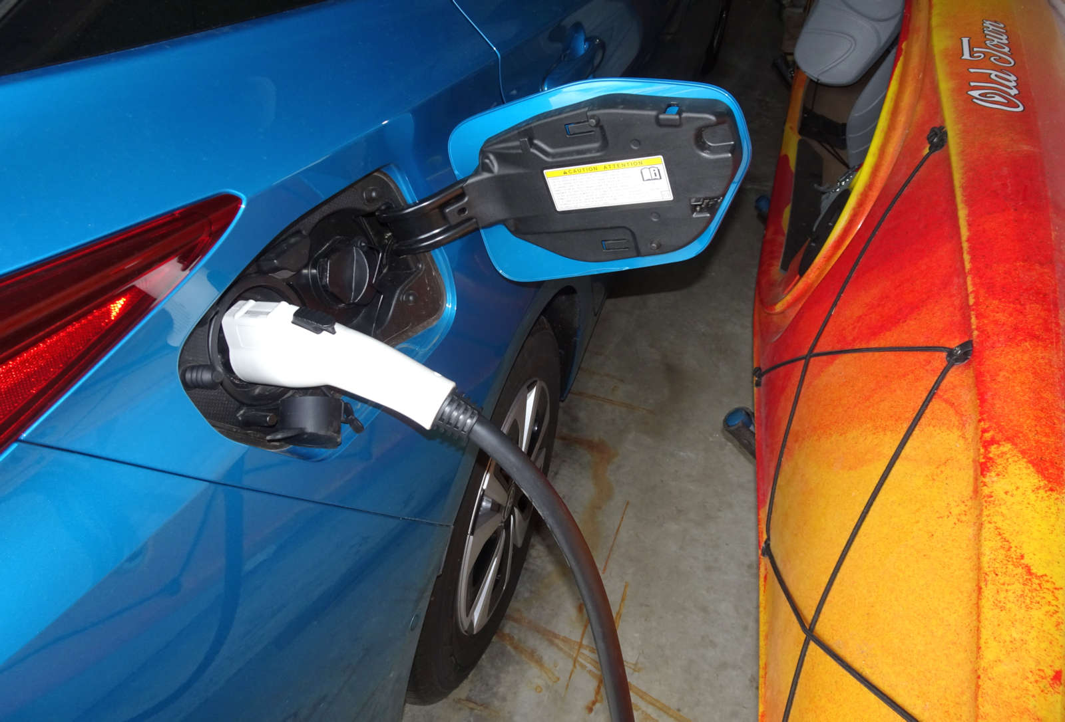
Charging Cost

6.25 kWh of electricity is required to completely replenish the EV driving capacity for Prius Prime. Billing from your electricity provider will be a per kWh (kilowatt-hour) rate. For example, if the rate was 12 cents per kWh, a full recharge would cost 75 cents.

kWh Pricing may be different for the time of day when charging takes place and may vary based upon the total amount your household uses each month. This is why owners looking to install a charger using a 240-volt connection consider the value of including a meter. With it, you may be able to take advantage of discounts, which have pricing based upon demand.

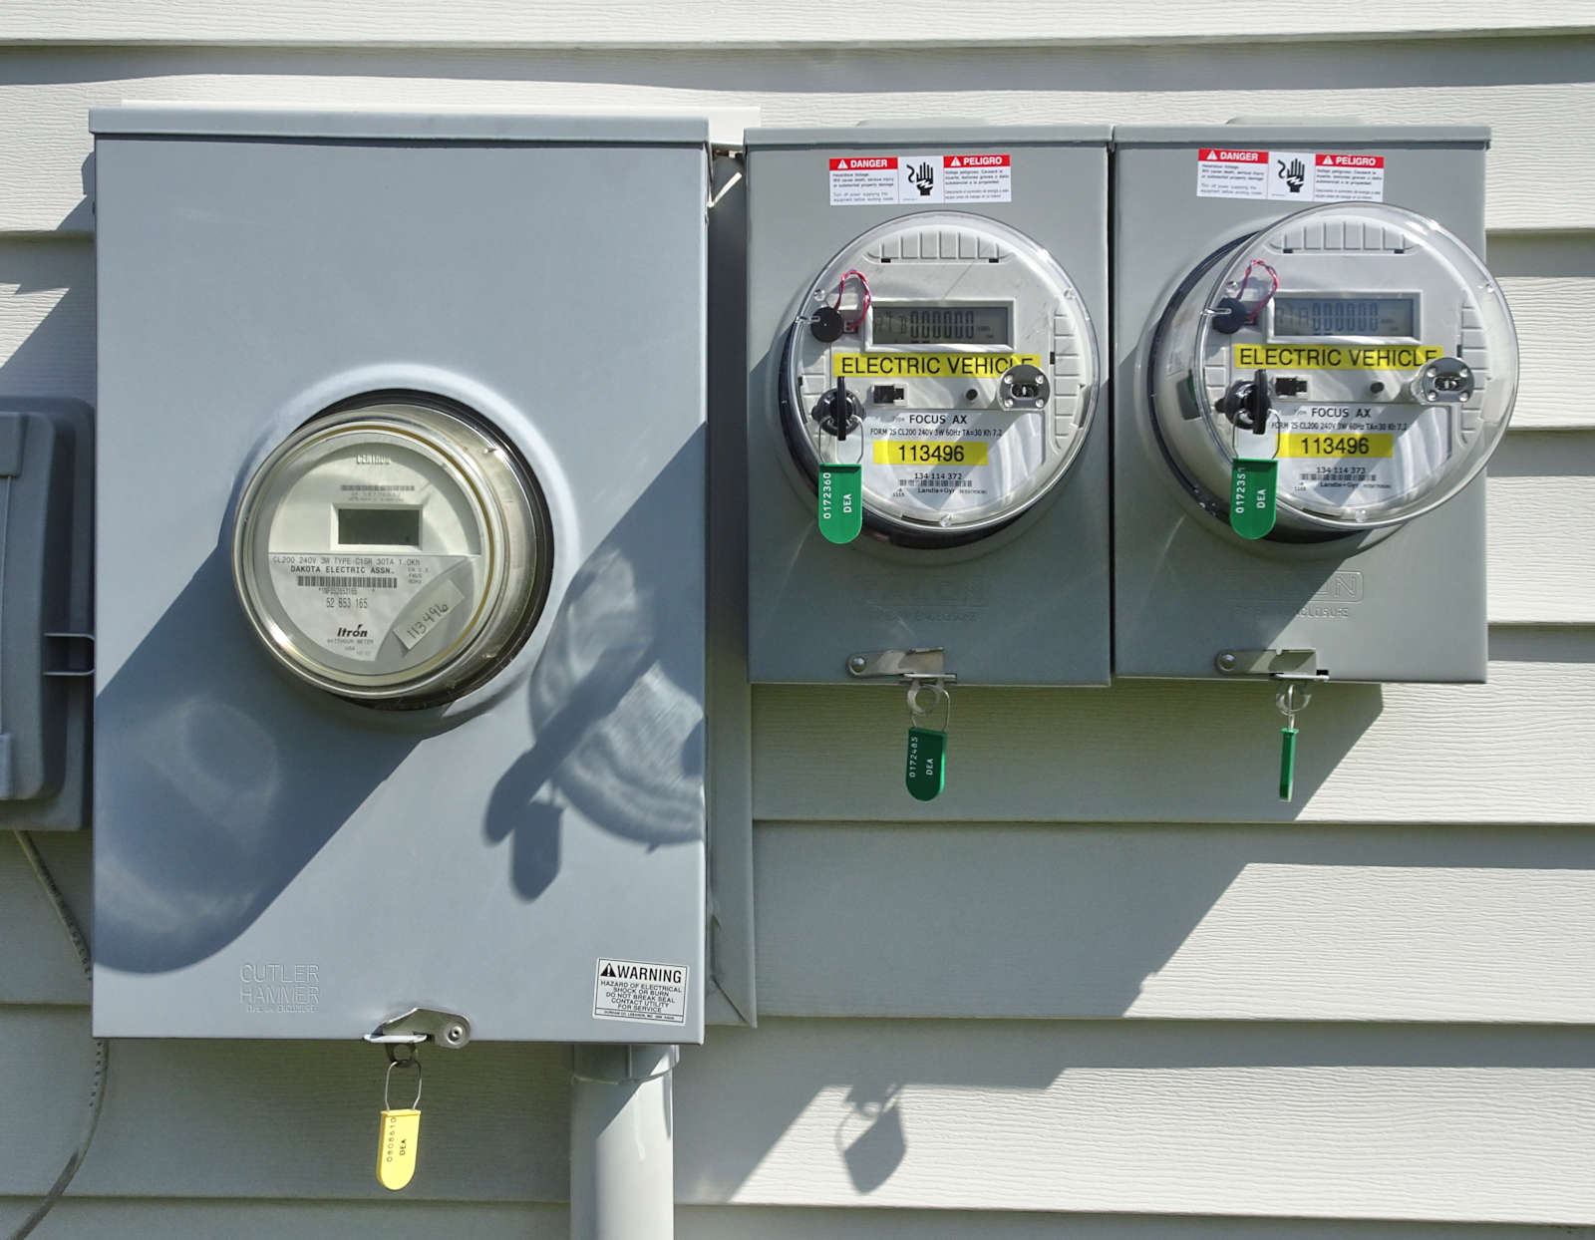
Meters for getting discounted charging rates from electricity providers vary. Some providers require a completely separate service, independent of your home’s current setup. This can expensive to install and often includes a monthly service fee. Others only require connecting a sub-meter to the existing service.

The photo above is an example of 2 sub-meters installed next to the main meter for the home. Each with its own 40-amp breaker powered directly from the 200-amp service-panel, electricity is provided & measured for the 2 independent high-speed chargers inside the garage. The screen on each meter displays kWh used totals for each discount category.

Time Of Day is a metered discount setup that does not restrict when you recharge your vehicle. You will be billed for the kWh of electricity used by the charger at a designated rate during that specific time. In this example, notice how pricing varies throughout the day:

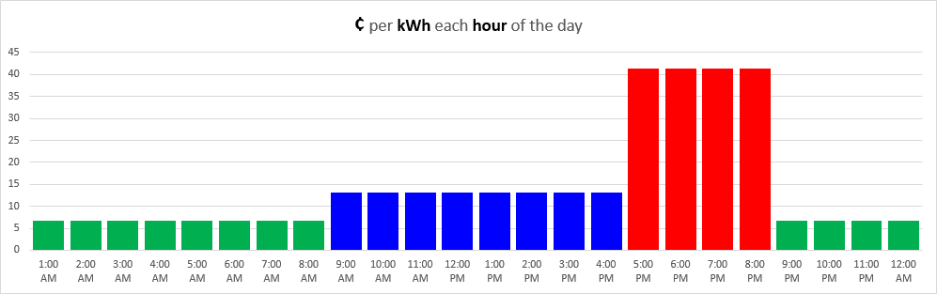

That expensive period (from 5 PM to 9 PM) is quite a bit more expensive than earlier in the day. This is due to the high demand for electricity during those few hours after getting home from work. Earlier in the day, the price per kWh is lower. Overnight is when the largest discounts are available. Holidays and weekends (all 48 hours) are typically discounted at the lowest rate too.

Off Peak is a metered discount setup focused exclusively for when electricity demand is at its lowest. This time period typically starts late in the evening and continues until early in the morning. You can take advantage of extremely reduced price due to higher electricity supply then. For example:

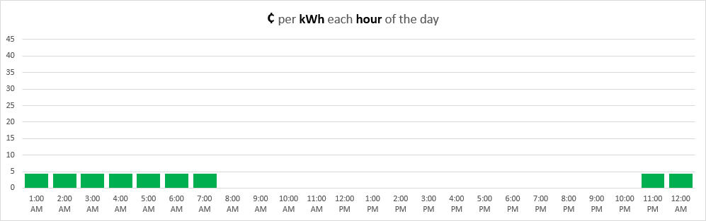

Notice that you cannot use your charger during the other hours of the day.

EVSE (Electric Vehicle Supply Equipment)

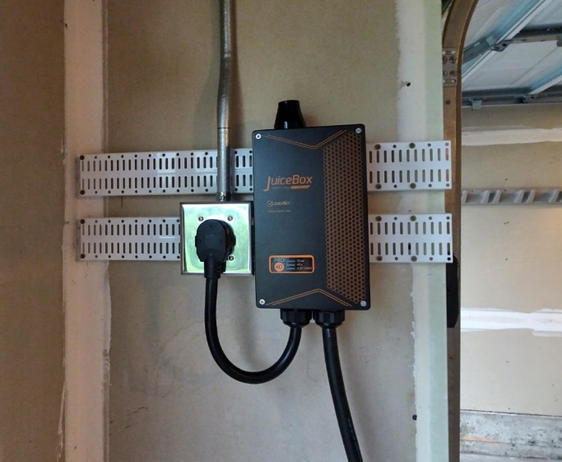

EVSE is the standard industry term for referring to a home charger for your plug-in vehicle. Pictured above is an example. It is the hardware needed to supply power from the electric outlet to the battery. Choices vary greatly, from basic & slow to providing very fast charging with remote interfaces. Prices can range from $250 to $1,000 units. Understanding options available will help you get the most from your purchase.

Plugging In

This common type of plug (known as J1772) is what Prius Prime uses. You'll find this at most public charging stations.

Both slow (120-volt, also known as “level 1”) and fast (240-volt, also known as “level 2”) chargers share the same connector handle.

Since connections are the same, you may want to consider purchase of a charger with greater capacity than what is needed for now. This is often referred to as “future proofing”.

240-Volt Service  Included with standard 120-volt service, your home also has 240-volt service. High demand electrical devices, such as A/C, clothes dryer, and electric oven, will use that higher power available. Your high-speed charger will too.  Charger Placement  An electrician will run new wires & conduit to provide an outlet for your charger. Select a location where the cord will be convenient. For example, the one shown to the right can be also used outside the garage, when you want to park in the driveway and still plug in.  Note that the electrician will need to determine if your home’s service has enough capacity to meet the needs of the high-speed charger. | 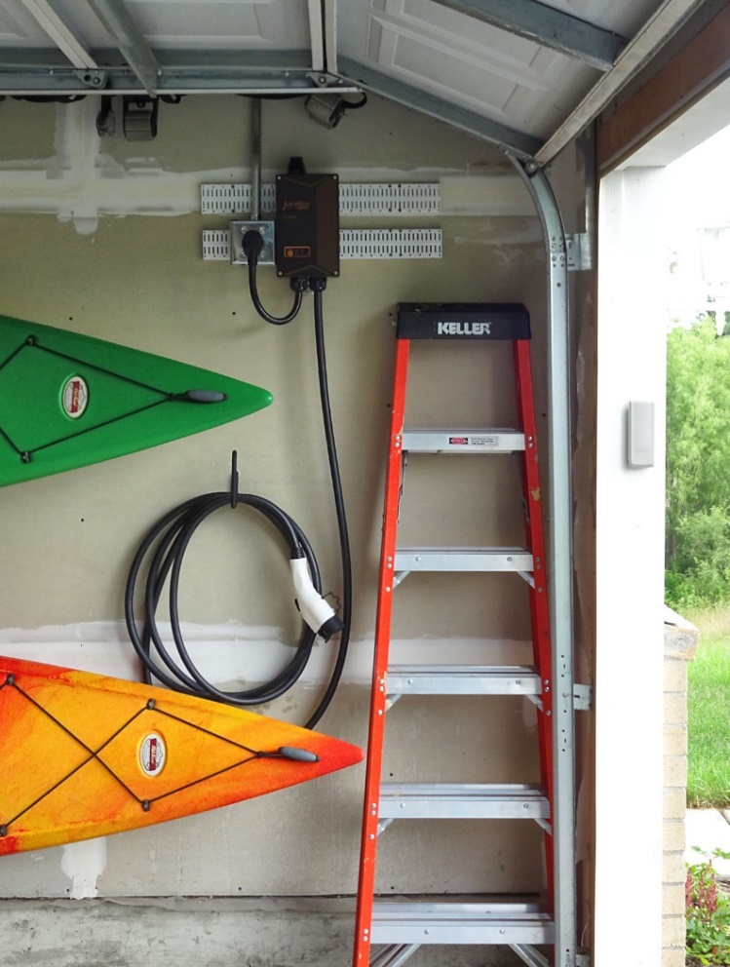

Charger Interface  Advanced chargers offer the ability to monitor progress, track history, schedule charging, and control usage.  This is done by connecting the charger using your home's Wi-Fi. This allows access to features with a computer or phone over the internet.  The phone-app shown to the right offers a convenient interface displaying helpful information about the charger's recent activity. | 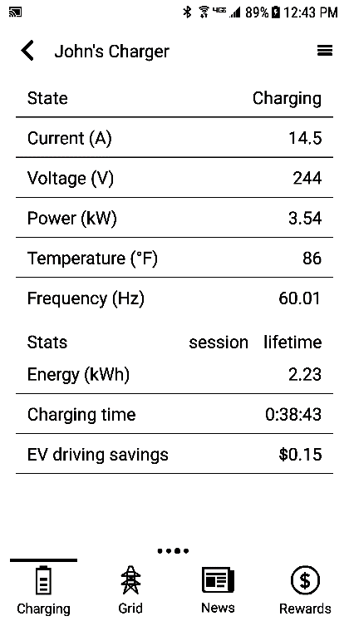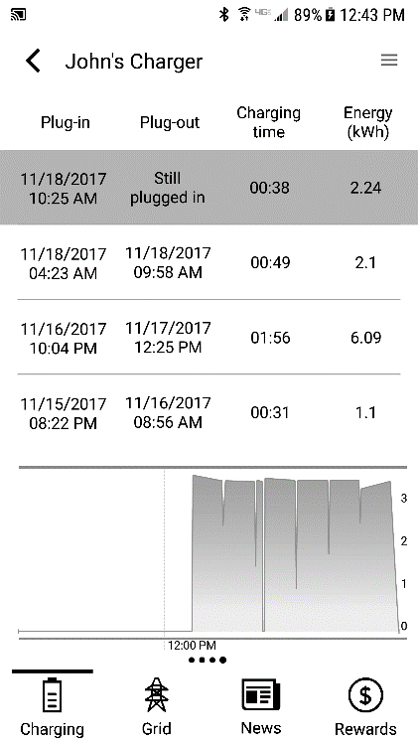

Charge Schedule  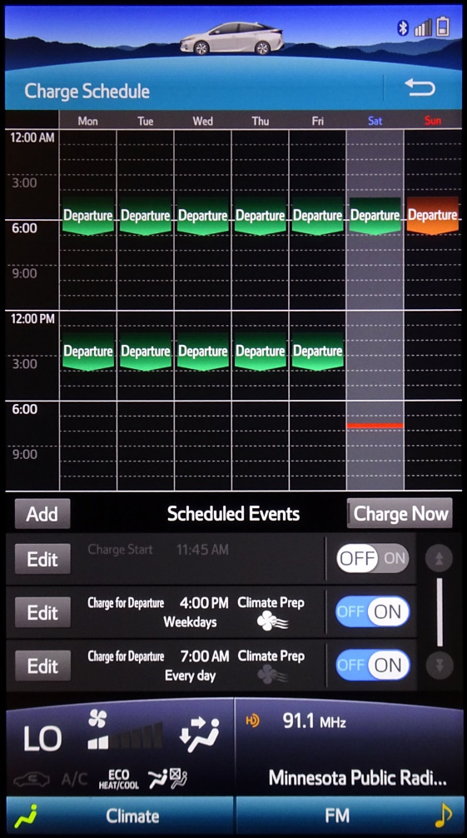 | Another way of prolonging battery life is to schedule charging for later, rather than having start immediately. The delay allows the battery to cool in the meantime, a process referred to as "cold soak".  With Prime you can schedule charging times, these are known as events.  There are a variety of options available. You can choose between specifying start or departure time. You can also specify whether or not to include climate-prep, a feature which will run the Heater or the A/C to make the cabin comfortable prior to you leaving. There is the option of scheduling multiple events in a single day as well.  Scheduled events may be edited on either the smaller interface or on the large screen.  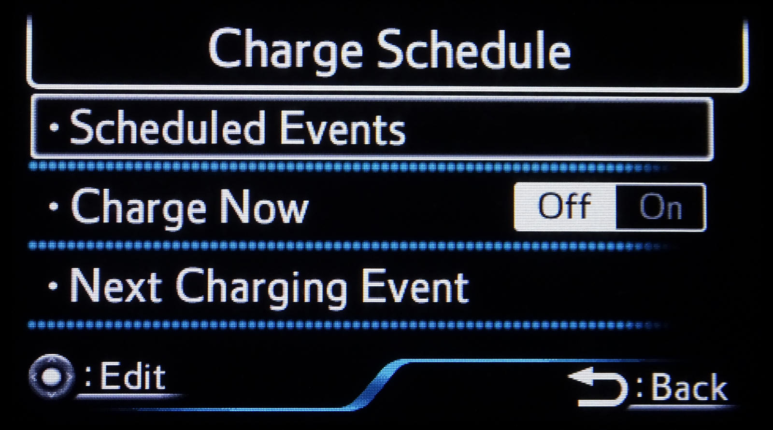
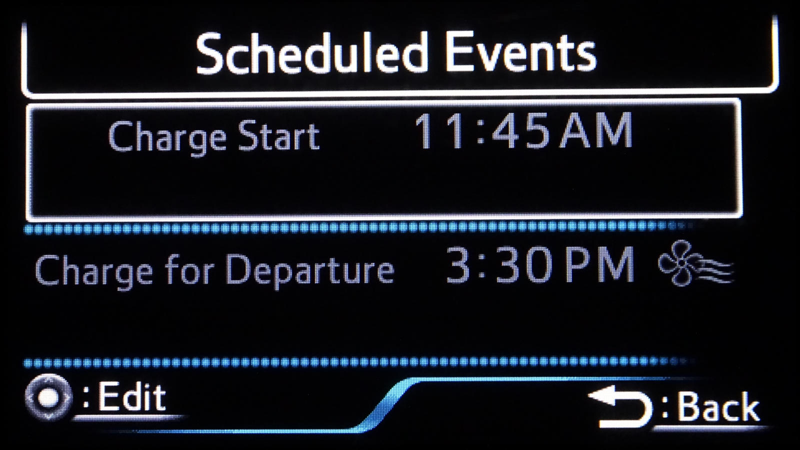 | 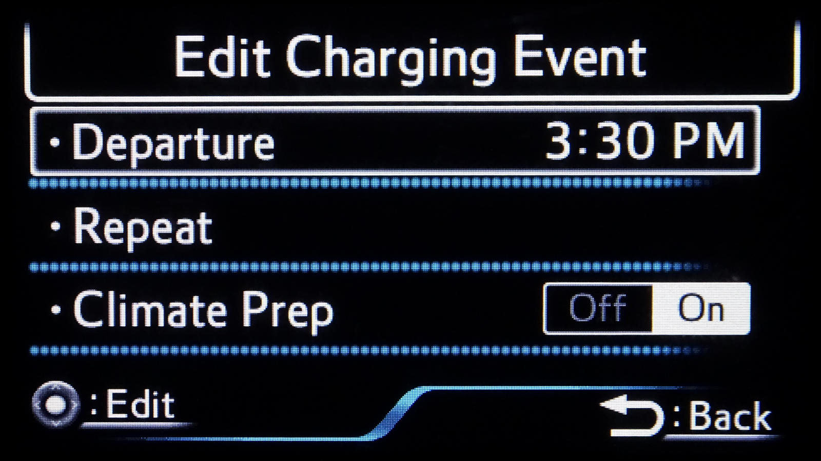
Battery Heat  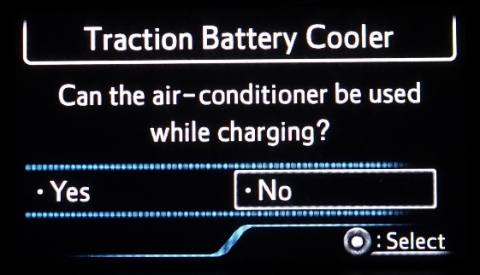 | Heat contributes to battery aging. This can be slowed by keeping it cool. When you shut off your Prime after driving on a hot day, this prompt will appear…  Selecting "Yes" will allow the A/C to run, cooling the interior of the vehicle, which in turn cools the battery.
Charge Now  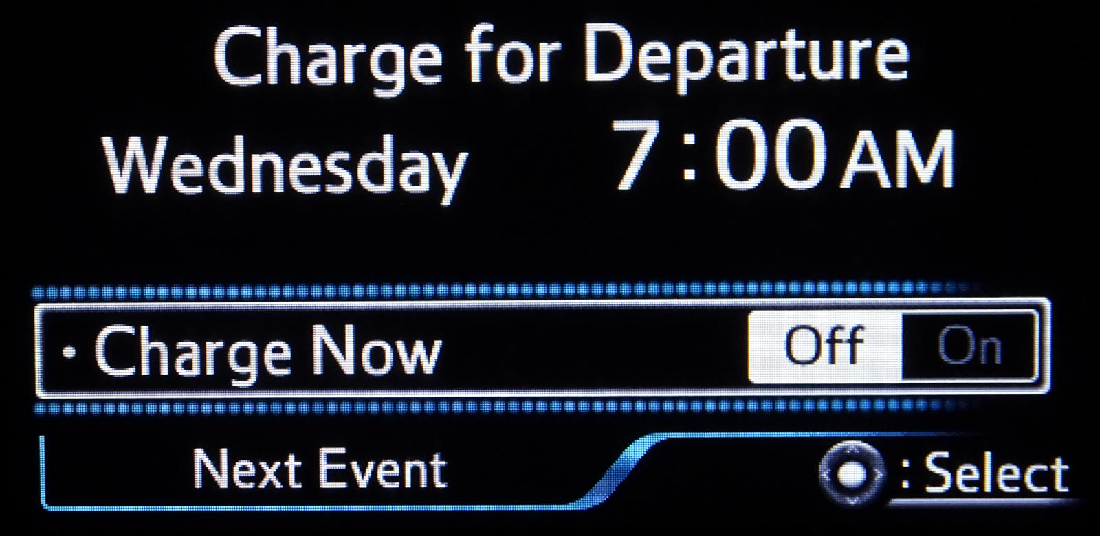  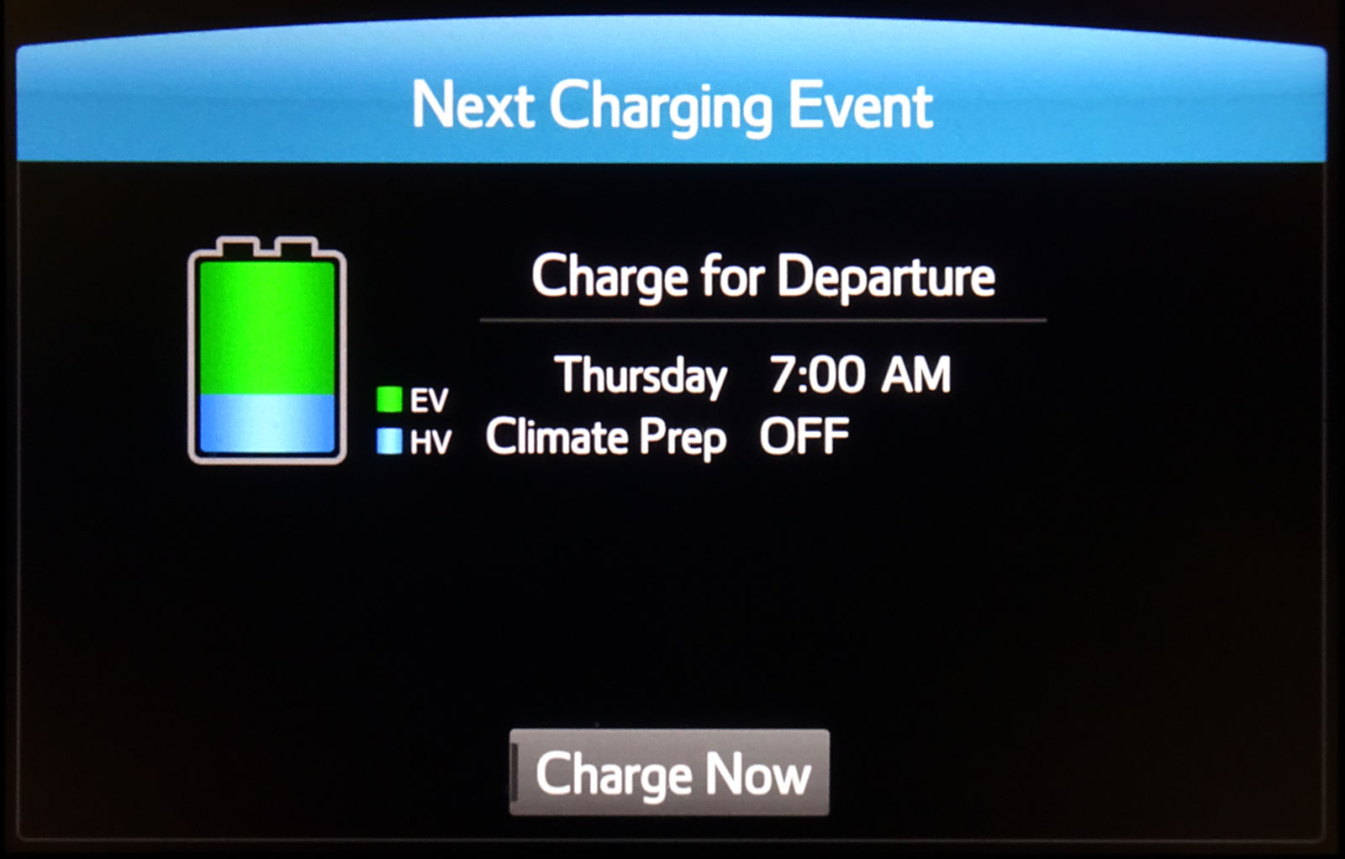 |  | If you want charging to begin immediately upon plugging in, use either of the two options.  This first option what's displayed when pressing the button for charging options, located to the left of the steering-wheel, on the underside of the dashboard close to the button for opening the fuel-door. It can be activated at any time, even when the Prime is shut off.  This second option is what you see upon shutting off the Prime. It appears only for a short time, but offers an easy method of selecting the "Charge Now" option. Rather than needing to click physical buttons to navigate, as with the other, this only requires a quick tap on the touch-screen.  Note that there is a third "Charge Now" option available. On the previous page, notice that button in the middle of the large Charge Schedule screen.

Charge Status  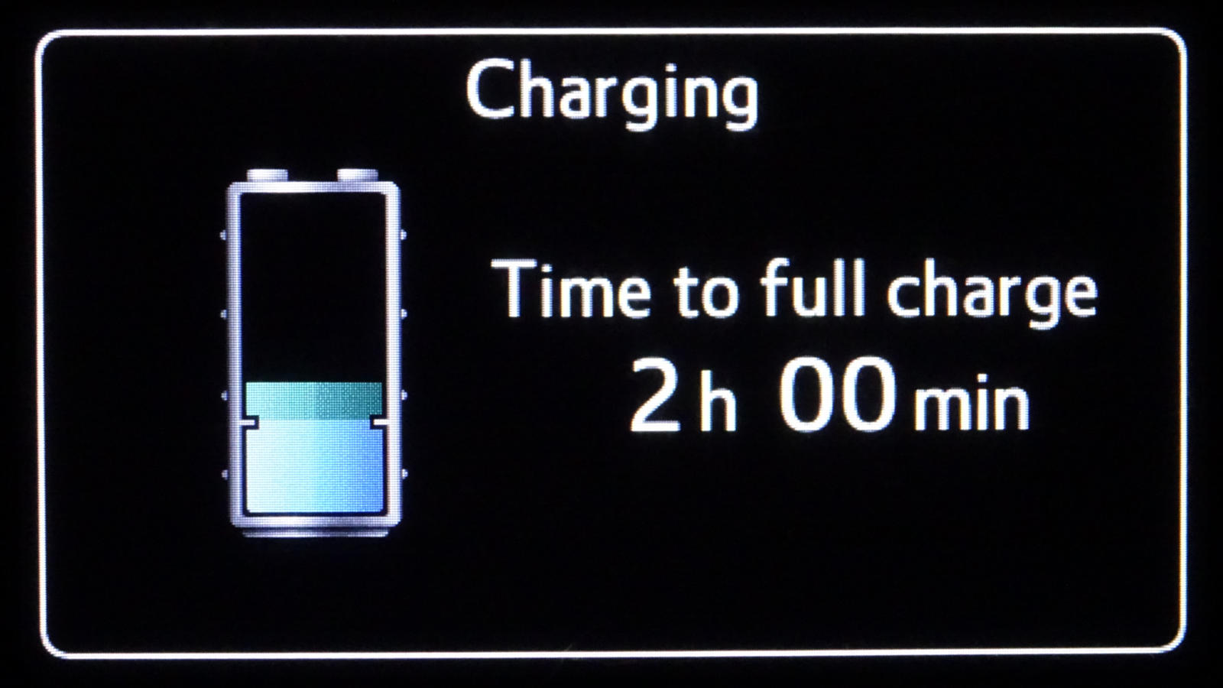 | While the Prime is off and plugged in, either in standby waiting to charge or while charging, open any of the doors or the rear hatch. This status of battery capacity available and time needed to complete a full charge is displayed automatically.

Charge Remaining  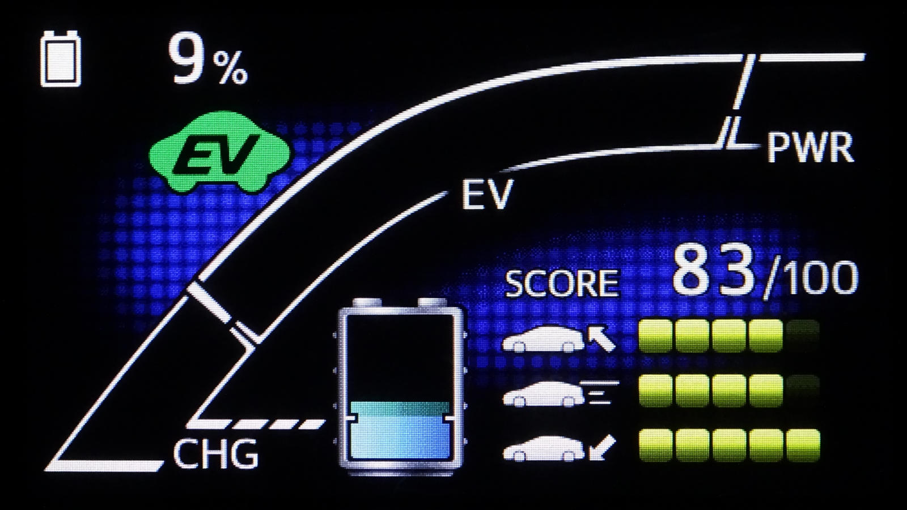 | Want to see the percentage of battery-capacity remaining instead of estimate EV distance?  From the "Meter Customize" menu option, select "HV System Indicator". Then on that screen, select "EV Drive Monitor". The choice to display percent is "EV Energy".  This value informs you of how much electricity is available, rather than seeing an approximation number of miles that could potentially be traveled.

Outlet or Hardwire

In the past, most fast chargers were permanently connected to your home electrical system by an electrician. This was known as a "hardwire" connection. Recently, the industry has shifted to offering choices with connections for standard 240-volt outlets. This makes the charger more convenient for consumers who already have an outlet available in their garage. It also provides an opportunity to bring the charger along on road trips where a 240-volt outlet may be available, like in a RV park (which provide standard NEMA 14-50 outlets.)

Wires & Conduit

The wires you have in each room of your home are enough to support the demands of everyday life. Charging a vehicle is more demanding. To supply that electricity to an outlet, a heavy gauge wire is required. Some homes have this already, others do not. To add new wires across a ceiling or along a wall, a metal pipe (called "conduit") is required to protect it. This adds to the cost of the upgrade, but is an easy way to avoid the complexity of opening up walls for wire placement inside.

Amp Level

The speed of charging is not just a factor of voltage, there is also the influence of amps (amperes) to take into consideration. Think of this as the size of a pipe water travels through; larger allows for more to pass even when the rate (voltage) is the same. If your vehicle is equipped to accept more, it will recharge faster. For example, a line setup to deliver 40 amps could send more power to the battery-pack than a line for 20 amps.

kW Rate

The actual speed which electricity is delivered to your vehicle is depicted in kW (kilowatt) rate. It's a universal measure focusing on the power as it is being sent through the wires. You'll see this number presented on the application for the charger, sometimes on the charger itself, and sometimes on the dashboard of your vehicle. It's important to know, since it can vary significantly. For example, if another vehicle is charging at the same time using the same line… like water from 2 hoses using the same spigot … the rate may be slower.

Non-Linear

Keep in mind that charging rate is non-linear. In other words, it is not always constant. At first, with a cool battery-pack and a dedicated power-source, you will typically see the fastest kW rate. But as charging approaches full capacity (or the battery-pack gets excessively hot), the kW rate will drop. This decrease is a normal behavior to ensure longevity. Slower is also used to for longevity when the battery-pack temperature while below freezing, then will increase as it warms.

Napkin Calculations

Each of the variables below can vary quite a bit. So, these calculations are nothing but rough estimates to provide a general idea of the benefit from plugging in. Remember that EV range will fluctuate based on temperature and electricity & gas prices will be different for you.

no recharge, 25 miles daily  25 miles * 365 days = 9,125 miles  9,125 miles / 54 MPG = 168.98 gallons  169.98 gallons * $2.599 per gallon = $441.78 gas  $441.78 overall cost per year for 9,125 miles; all HV | no recharge, 50 miles daily  50 miles * 365 days = 18,250 miles  18,250 miles / 54 MPG = 337.96 gallons  337.96 gallons * $2.599 per gallon = $878.36 gas  $878.36 overall cost per year for 18,250 miles; all HV
1 recharge, 25 miles daily, no discount  6.25 kWh * 12.04 cents per kWh * 365 days = $274.66 electricity  25 miles * 365 days = 9,125 miles  $274.66 overall cost per year for 9,125 miles; all EV | 1 recharge, 50 miles daily  6.25 kWh * 7.10 cents per kWh * 365 days = $161.97 electricity  25 miles * 365 days = 9,125 miles  9,125 miles / 54 MPG = 169.98 gallons  169.98 gallons * $2.599 per gallon = $441.78 gas  $603.75 overall cost per year for 18,250 miles; half EV, half HV
1 recharge, 25 miles daily, TOU discount  6.25 kWh * 7.10 cents per kWh * 365 days = $161.97 electricity  25 miles * 365 days = 9,125 miles  $161.97 overall cost per year for 9,125 miles; all EV | 2 recharges, 50 miles daily, TOU discount 1 charge  6.25 kWh * 7.10 cents per kWh * 365 days = $161.97 electricity  6.25 kWh * 12.04 cents per kWh * 365 days = $274.66 electricity  50 miles * 365 days = 18,250 miles  $436.63 overall cost per year for 18,250 miles; all EV

