
Prius PHV
First-Year Report



Real-World Data
Many years ago, there was much doubt about hybrids, those cars with both a combustion engine and an electric motor. Fortunately, most of the misconceptions from back then have since been proven false and forgotten, no longer impairing the spread of the cleaner and more efficient technology. Even the implied stigma from those hoping to undermine progress has faded. It’s now common to see hybrids every time you drive… so common, the next step has been taken by automakers: the introduction of a plug.
Full hybrids (like Prius) utilize a power-split device. This delivers the ability to vary the power & direction of energy by connecting a motor for traction, a motor for generating electricity, and an engine. The flexibility provides a wide array of behavior which can rapidly change from one mode to another. That means being able to both create & consume electricity at the same time, resulting in a very efficient way of using it for propulsion and recharging the battery-pack. Adding a plug increases efficiency opportunities.
As with regular hybrids, success depends upon real-world data. Automakers advertisements cannot convey the complexities & expectations of ownership. Owners can. Their endorsements are a powerful tool for educating & informing. This document supplies detail of owning a 2012 Prius PHV, the plug-in model.
Note: Standard household outlets, the common 110/120 volt connection we all have in our homes, is all that’s needed for recharging Prius PHV. From “empty” (battery-pack level of about 23%) it will take 2.5 hours to recharge to “full” (battery-pack level to 85%). A faster 220/240 volt connection is available. It reduces recharge time to 1.5 hours. But the extra expense of purchasing that faster charger isn’t necessary. The 110/120 included with purchase is all owners recharging overnight will ever need.

Annual Totals
The following are the totals, spanning from March 11, 2012 to March 10, 2013:

18,477 | Total Miles
6,328 | EV Miles (displayed amount)
12,123 | HV Miles (displayed amount)
365 | Days (12 months)
574 | Recharges (based on capacity replenished)
239.9 | Total Gallons (measured at the pump)
1,721 | Total kWh (including charging losses)
1,505 | Total kWh (displayed amount)
77.0 | Lifetime MPG
50.5 | MPG (HV)
27 | kWh / 100 miles

Those numbers in the summary are from an owner in Minnesota, where extreme cold temperature driving reduces efficiency in all types of vehicles. Driving roughly 19,000 miles per year is another above average factor to consider. The few miles you drive, the higher MPG can be. More electricity usage translates to better efficiency. This is true even when the engine runs. That means HV miles benefit from having plug-supplied electricity available too.
Each owner’s driving circumstances are different. This is why the window-sticker always comes with a YMMV (Your Mileage May Vary) warning. With the case of a plug being included, change that “May” to a “Will”. Nonetheless, real-world data is still an important means of measuring the effectiveness of the technology.
What is clear though is the efficiency improvement the larger battery-pack and plug provide. The resulting MPG is well above what a regular Prius would deliver.
Note: With the owner data above, it is important to be aware that a charging-station was available at work and was used most afternoons prior to the commute home. The commute itself was about 34 miles round-trip. Lots of other driving during evenings and on weekends also took place. Shorter commutes, less frequent driving, or not recharging a second time daily would result in different MPG.

Daily Miles - Summary
Don’t be fooled by generalized estimates claiming standard daily-driving quantities. Most people assume they follow a routine. You’d be surprised how often the demands of life cause unpredictable variation. There usually isn’t a pattern to the driving. This real-world data clearly shows that:
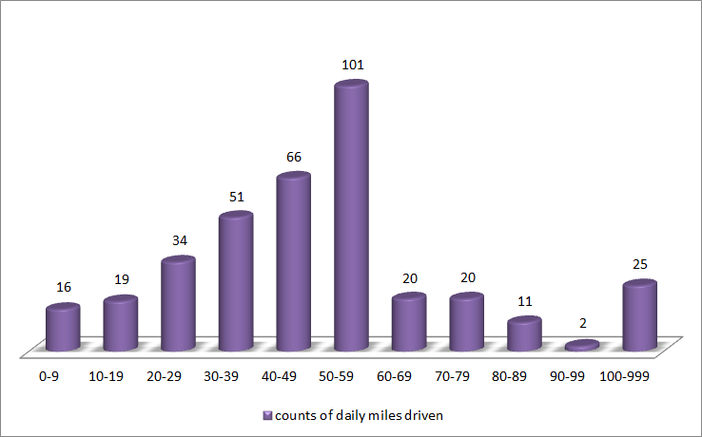

Think about how often you run to the store for household items, buy groceries, meet a friend, visit family, go to a theater, eat at a restaurant, get a coffee, pick up a prescription, rent a movie or game, go to the bank, have late night food cravings… the list of possible non-work driving you could routinely do is extensive. That doesn’t even include any of the running around you do for your children.

Daily Miles - Detail
That cliché pointing out “the devil is in the detail” most definitely applies when it comes to a plug-in hybrid like Prius. Use of the plug-supplied electricity varies greatly, even when consistently charge once or twice per day. It’s very important to remember that when miles are not logged as EV, the miles in HV still take advantage of the battery-pack.
Notice the variation. The lack of any pattern becomes quite evident when the real-world data is plotted in a daily graph like these:
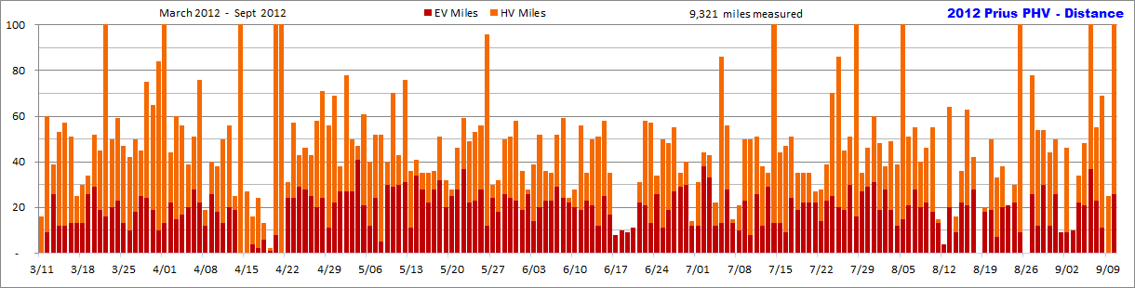
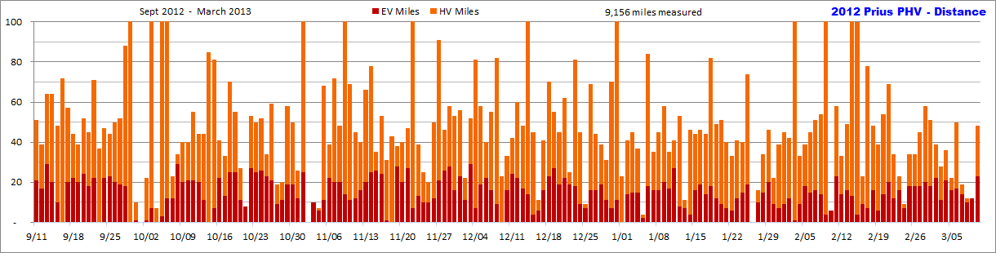

Coinciding with the EV & HV mile data is the detail for MPG. Each day varies widely, which is very easy to see:
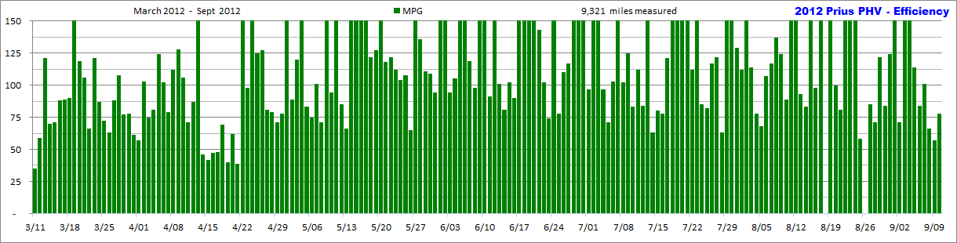
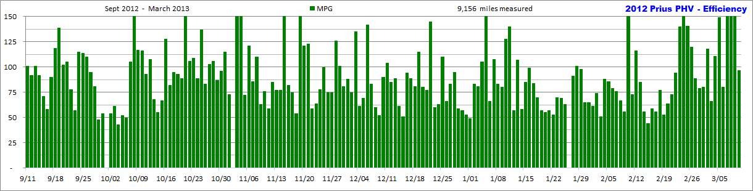
The benefit of the plug and larger battery-pack is obvious. Notice that most days are well the 50 MPG mark.

Tank Efficiency - Summary
Based on gas consumption and total miles driven, these graphs are 2 different ways of showing the efficiency results, per tank & per month:
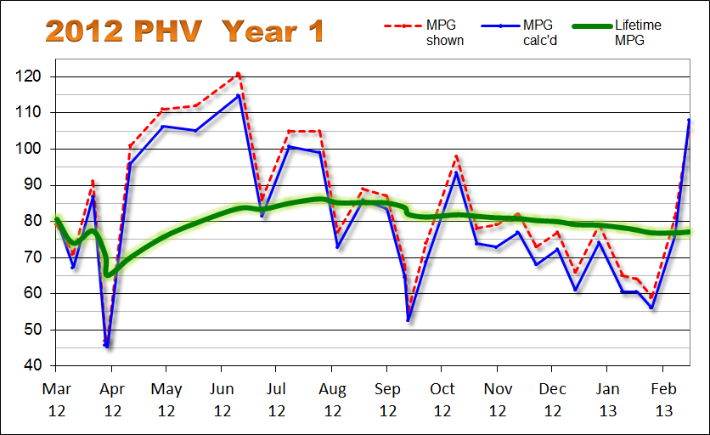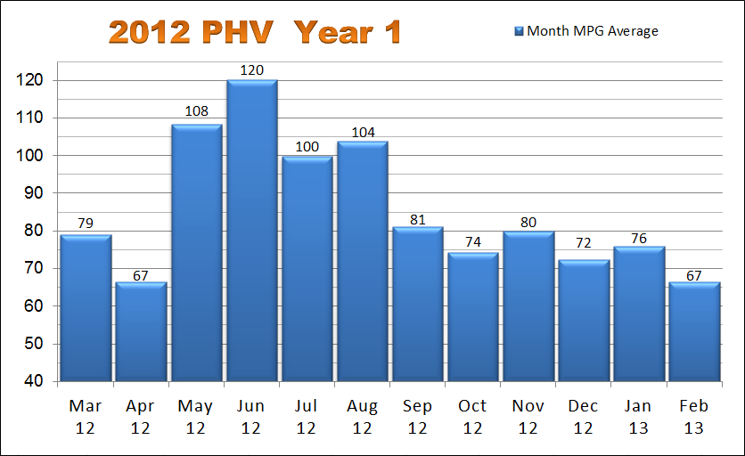
In both, you can clearly see the variation caused by season change. Many factors influence the outcome. But even without know how & why detail, it’s easy to confirm the same type of up & down with traditional vehicles applies to the hybrid as well. Fortunately, the resulting MPG itself is quite a bit better.
Notice that green line in the “per tank” graph on the left? That’s the lifetime MPG value. It’s a running total illustrating the overall average taking the entire year’s worth of data into account. This is what ultimately informs the owner of what their particular gas consumption level is for ownership of the vehicle.

Combining gallons of gas with kWh of electricity results in a new type of efficiency measure, called “MPGe”.
Notice how different it appears compared to just gallons of gas alone:
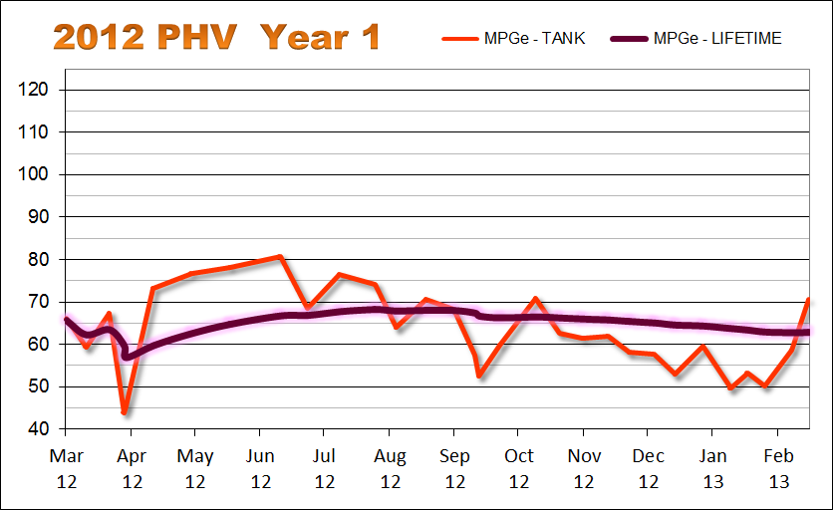

The purpose is to take all forms of energy into account, conveying a complete picture of efficiency.

This is the formula used: MPGe = (# EV miles + # HV miles) / ((# kWh / 32.6 kWh) + # gallons)
32.6 kWh represents the electrical equivalent of one gallon of E10
33.7 kWh represents the electrical equivalent of one gallon of 100% gas
kWh value from the real-world data must include charging losses.

Tank Efficiency - Detail
These are the values documented each time the gas tank was refilled. Notice the difference between shown (computer displayed) quantities and the pump & outlet measurements. Study closely the relation between electricity (kWh) & gas (gallons), how they influence efficiency results. Don’t forget about season influence either. The real-world data is far from the simple estimates people assume and those greenwashers attempt to convince you of.
 | MPG  shown | MPG  calc'd | Lifetime  MPG | EV | HV | Total  Miles | Gallons | Total  Gallons | Recharges | kWh  shown | kWh  calc'd | Total  kWh | MPG (HV) | kWh /  100 miles | Lifetime  kWh/100m  calc'd
3/24/2012 | 79 | 80.6 | 80.6 | 237 | 448 | 685 | 8.504 | 8.504 | 21.0 | 60 | 63.0 | 63.0 | 52.7 | 26.6 | 26.6
4/02/2012 | 71 | 67.2 | 73.9 | 157 | 418 | 1,255 | 8.477 | 16.981 | 13.7 | 36 | 41.1 | 104.1 | 49.3 | 26.2 | 26.4
4/13/2012 | 91 | 86.8 | 77.3 | 214 | 305 | 1,775 | 5.988 | 22.969 | 19.3 | 53 | 57.9 | 162.0 | 50.9 | 27.1 | 26.6
4/20/2012 | 47 | 45.8 | 70.4 | 17 | 279 | 2,072 | 6.481 | 29.450 | 2.9 | 4 | 8.7 | 170.7 | 43.0 | 51.2 | 27.3
4/21/2012 | 47 | 45.3 | 65.0 | 9 | 357 | 2,438 | 8.072 | 37.522 | 0.0 | 0 | 0.0 | 170.7 | 44.2 | 0.0 | 26.9
5/04/2012 | 101 | 96.0 | 70.0 | 329 | 371 | 3,140 | 7.314 | 44.836 | 25.2 | 69 | 75.6 | 246.3 | 50.7 | 23.0 | 25.6
5/22/2012 | 111 | 106.2 | 75.6 | 454 | 393 | 3,998 | 8.077 | 52.913 | 33.3 | 92 | 99.9 | 346.2 | 48.7 | 22.0 | 24.4
6/09/2012 | 112 | 105.1 | 79.4 | 407 | 444 | 4,840 | 8.015 | 60.928 | 32.3 | 88 | 96.9 | 443.1 | 55.4 | 23.8 | 24.3
7/03/2012 | 121 | 114.9 | 83.5 | 479 | 432 | 5,752 | 7.938 | 68.866 | 37.5 | 104 | 112.5 | 555.6 | 54.4 | 23.5 | 24.1
7/16/2012 | 86 | 81.4 | 83.3 | 218 | 449 | 6,421 | 8.222 | 77.088 | 17.0 | 46 | 51.0 | 606.6 | 54.6 | 23.4 | 24.1
7/31/2012 | 105 | 100.8 | 84.9 | 346 | 457 | 7,225 | 7.977 | 85.065 | 28.4 | 77 | 85.2 | 691.8 | 57.3 | 24.6 | 24.1
8/17/2012 | 105 | 99.1 | 86.1 | 325 | 452 | 8,002 | 7.841 | 92.906 | 29.8 | 79 | 89.4 | 781.2 | 57.6 | 27.5 | 24.5
8/27/2012 | 77 | 72.9 | 85.1 | 150 | 434 | 8,587 | 8.028 | 100.934 | 12.4 | 33 | 37.2 | 818.4 | 54.1 | 24.8 | 24.5
9/10/2012 | 89 | 85.9 | 85.1 | 254 | 474 | 9,316 | 8.490 | 109.424 | 20.5 | 53 | 61.5 | 879.9 | 55.8 | 24.2 | 24.5
9/23/2012 | 87 | 83.5 | 85.0 | 228 | 458 | 10,002 | 8.213 | 117.637 | 20.6 | 57 | 61.8 | 941.7 | 55.8 | 27.1 | 24.6
10/03/2012 | 68 | 64.6 | 83.7 | 106 | 406 | 10,515 | 7.937 | 125.574 | 10.9 | 26 | 32.7 | 974.4 | 51.2 | 30.8 | 24.8
10/05/2012 | 55 | 52.5 | 81.9 | 11 | 399 | 10,924 | 7.797 | 133.371 | 0.0 | 0 | 0.0 | 974.4 | 51.2 | 0.0 | 24.7
10/15/2012 | 74 | 68.8 | 81.1 | 156 | 412 | 11,493 | 8.267 | 141.638 | 13.9 | 36 | 41.7 | 1016.1 | 49.8 | 26.7 | 24.8
11/01/2012 | 98 | 93.5 | 81.8 | 311 | 378 | 12,182 | 7.371 | 149.009 | 26.4 | 71 | 79.2 | 1095.3 | 51.3 | 25.5 | 24.8
11/12/2012 | 78 | 73.8 | 81.3 | 164 | 430 | 12,777 | 8.061 | 157.070 | 16.0 | 40 | 48.0 | 1143.3 | 53.3 | 29.3 | 25.0
11/23/2012 | 79 | 72.9 | 80.9 | 201 | 398 | 13,377 | 8.234 | 165.304 | 17.0 | 42 | 51.0 | 1194.3 | 48.3 | 25.4 | 25.0
12/05/2012 | 82 | 77.0 | 80.7 | 218 | 406 | 14,003 | 8.128 | 173.432 | 21.8 | 57 | 65.4 | 1259.7 | 50.0 | 30.0 | 25.2
12/15/2012 | 73 | 68.1 | 80.2 | 149 | 403 | 14,555 | 8.103 | 181.535 | 15.8 | 40 | 47.4 | 1307.1 | 49.7 | 31.8 | 25.4
12/27/2012 | 77 | 72.3 | 79.8 | 206 | 366 | 15,128 | 7.923 | 189.458 | 22.6 | 59 | 67.8 | 1374.9 | 46.2 | 32.9 | 25.7
1/06/2013 | 66 | 60.9 | 79.1 | 119 | 380 | 15,629 | 8.221 | 197.679 | 13.6 | 35 | 40.8 | 1415.7 | 46.2 | 34.3 | 25.9
1/19/2013 | 79 | 74.2 | 78.9 | 199 | 391 | 16,219 | 7.954 | 205.633 | 22.2 | 56 | 66.6 | 1482.3 | 49.2 | 33.5 | 26.2
2/01/2013 | 65 | 60.5 | 78.2 | 140 | 353 | 16,712 | 8.149 | 213.782 | 20.1 | 48 | 60.3 | 1542.6 | 43.3 | 43.1 | 26.6
2/09/2013 | 64 | 60.6 | 77.5 | 93 | 387 | 17,194 | 7.954 | 221.736 | 11.9 | 29 | 35.7 | 1578.3 | 48.7 | 38.4 | 26.8
2/17/2013 | 59 | 56.1 | 76.8 | 93 | 369 | 17,658 | 8.268 | 230.004 | 10.6 | 24 | 31.8 | 1610.1 | 44.6 | 34.2 | 26.9
3/02/2013 | 81 | 75.8 | 76.7 | 210 | 368 | 18,238 | 7.651 | 237.655 | 24.7 | 59 | 74.1 | 1684.2 | 48.1 | 35.3 | 27.2
3/10/2013 | 106 | 107.9 | 77.0 | 128 | 106 | 18,477 | 2.214 | 239.869 | 12.4 | 32 | 37.2 | 1721.4 | 47.9 | 29.1 | 27.2
Plug Efficiency - Summary
Based on electricity consumption and EV miles driven, these graphs are 2 different ways of showing the efficiency results, per tank & per month:
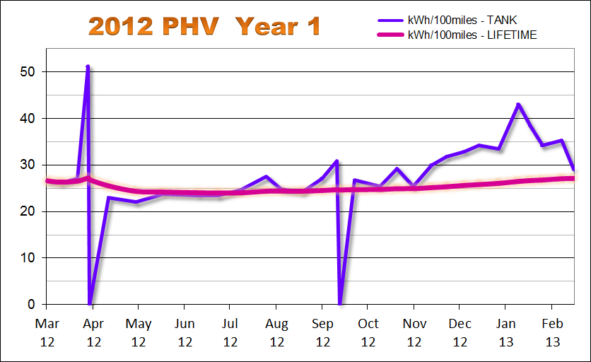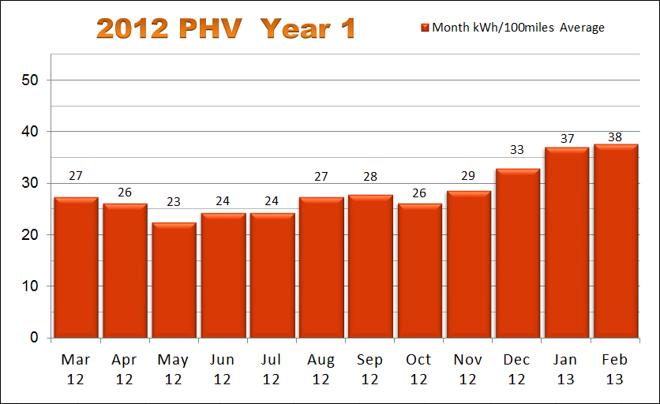
The purpose of this information is to give a general idea of the efficiency coming from the traction motor specifically. It documents electricity usage only. This is why only the EV miles are used in the calculations, not overall miles which would also include HV miles.
The unit of measure for this is “kWh/100miles”, indicating the quantity of electricity it takes to travel 100 miles. This is very different from the efficiency MPG measures.
Note: When tank data on the graph drops all the way to zero, that indicates driving was done without plugging. For example, a road-trip was taken without outlet or recharger access available.

Plug kWh - Summary
This particular graph visually depicts the quantity of electricity consumed per month, in units of kWh:
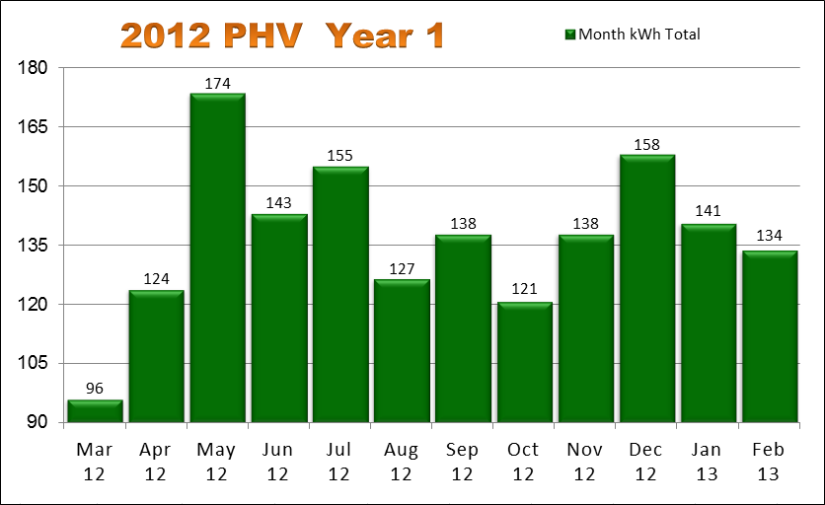

Don’t forget that the recharging process itself consumes electricity. This is known as “charging loss”. Some sources of electricity consumption only report the kWh extracted from the battery-pack, excluding the loss. Not accounting for that extra electricity is very misleading.
Prius PHV has a 4.4 kWh size battery-pack. Approximately 62% is used for EV miles. That translates to roughly 2.75 kWh being used for EV travel when that entire available capacity is used. 3 kWh is how much owners typically observe from meters measuring the quantity of electricity used to replenish that capacity while recharging.

Month - Detail
Some of the prior graphs originated from the calculation results found in this matrix:

 | MPG | Miles | Gallons | kWh | kWh/100m
Mar - 12 | 79.1 | 1,100 | 13.915 | 96.0 | 27.4
Apr - 12 | 66.5 | 1,828 | 27.481 | 123.9 | 26.2
May - 12 | 108.4 | 1,546 | 14.261 | 173.7 | 22.6
Jun - 12 | 120.2 | 1,161 | 9.659 | 143.1 | 24.5
Jul - 12 | 99.8 | 1,594 | 15.978 | 155.1 | 24.4
Aug - 12 | 103.9 | 1,570 | 15.111 | 126.6 | 27.5
Sep - 12 | 81.1 | 1,691 | 20.846 | 138.0 | 27.9
Oct - 12 | 74.3 | 1,679 | 22.589 | 120.9 | 26.3
Nov - 12 | 80.0 | 1,565 | 19.557 | 138.0 | 28.7
Dec - 12 | 72.4 | 1,647 | 22.754 | 158.1 | 33.0
Jan - 13 | 75.9 | 1,291 | 17.012 | 140.7 | 37.0
Feb - 13 | 66.6 | 1,477 | 22.182 | 133.8 | 37.7
Mar - 13 | 100.8 | 328 | 3.255 | 49.5 | 30.2
TOTAL | 82.3 | 18,477 | 224.600 | 1,697.4 | 28.2

That monthly detail was based upon the real-world daily data collected as well as the values documented each time the gas tank was refilled.

Daily - Detail
The following are real-world owner log entries, the complete collection of daily detail that was used to create the summary & graphs:

Date | ODO | MPG | Charges | EV | HV | calc'd  gallons | tank  gallons
Sun - Mar 11 | 16 | 35 | - | - | 16 | 0.46
Mon - Mar 12 | 75 | 59 | 1.0 | 9 | 51 | 1.00
Tue - Mar 13 | 115 | 121 | 2.0 | 26 | 13 | 0.33
Wed - Mar 14 | 169 | 70 | 1.0 | 12 | 41 | 0.77
Thu - Mar 15 | 227 | 71 | 1.0 | 12 | 45 | 0.82
Fri - Mar 16 | 279 | 88 | 2.0 | 13 | 38 | 0.59
Sat - Mar 17 | 304 | 89 | 1.0 | 13 | 12 | 0.28
Sun - Mar 18 | 335 | 90 | 1.0 | 13 | 17 | 0.34
Mon - Mar 19 | 371 | 209 | 2.0 | 26 | 8 | 0.17
Tue - Mar 20 | 424 | 119 | 2.0 | 29 | 23 | 0.45
Wed - Mar 21 | 470 | 106 | 2.0 | 19 | 26 | 0.43
Thu - Mar 22 | 574 | 66 | 2.0 | 16 | 87 | 1.58
Fri - Mar 23 | 625 | 121 | 2.0 | 20 | 30 | 0.42
Sat - Mar 24 | 685 | 87 | 2.0 | 23 | 36 | 0.69 | 21.0
Sun - Mar 25 | 733 | 72 | 1.0 | 13 | 34 | 0.67
Mon - Mar 26 | 776 | 63 | 1.0 | 10 | 32 | 0.68
Tue - Mar 27 | 827 | 88 | 2.0 | 18 | 32 | 0.58
Wed - Mar 28 | 873 | 108 | 2.0 | 25 | 20 | 0.43
Thu - Mar 29 | 949 | 77 | 2.0 | 24 | 51 | 0.99
Fri - Mar 30 | 1,015 | 78 | 2.0 | 19 | 46 | 0.85
Sat - Mar 31 | 1,100 | 61 | 1.0 | 10 | 74 | 1.39
Sun - Apr 01 | 1,215 | 57 | 1.0 | 13 | 101 | 2.02
Mon - Apr 02 | 1,260 | 103 | 1.7 | 22 | 22 | 0.44 | 13.7
Tue - Apr 03 | 1,321 | 75 | 1.9 | 15 | 45 | 0.81
Wed - Apr 04 | 1,378 | 81 | 1.7 | 17 | 39 | 0.70
Thu - Apr 05 | 1,418 | 124 | 2.0 | 20 | 19 | 0.32
Fri - Apr 06 | 1,470 | 102 | 2.0 | 28 | 23 | 0.51
Sat - Apr 07 | 1,548 | 79 | 2.0 | 22 | 54 | 0.99
Sun - Apr 08 | 1,568 | 112 | 0.9 | 12 | 7 | 0.18
Mon - Apr 09 | 1,609 | 128 | 2.0 | 26 | 14 | 0.32
Tue - Apr 10 | 1,647 | 106 | 2.0 | 18 | 20 | 0.36
Wed - Apr 11 | 1,698 | 71 | 1.0 | 13 | 37 | 0.72
Thu - Apr 12 | 1,755 | 87 | 2.0 | 20 | 36 | 0.66
Fri - Apr 13 | 1,781 | 170 | 1.8 | 19 | 6 | 0.15 | 19.3
Sat - Apr 14 | 1,970 | 46 | 1.0 | - | 188 | 4.11
Sun - Apr 15 | 1,998 | 42 | - | - | 27 | 0.67
Mon - Apr 16 | 2,016 | 47 | 0.9 | 4 | 12 | 0.38
Tue - Apr 17 | 2,041 | 48 | - | 2 | 22 | 0.52
Wed - Apr 18 | 2,055 | 69 | - | 6 | 7 | 0.20
Thu - Apr 19 | 2,057 | 40 | 1.0 | 1 | 1 | 0.05
Fri - Apr 20 | 2,234 | 62 | - | 8 | 168 | 2.85 | 2.9
Sat - Apr 21 | 2,445 | 39 | - | - | 210 | 5.41 | -
Sun - Apr 22 | 2,477 | 196 | 2.0 | 24 | 7 | 0.16
Mon - Apr 23 | 2,535 | 98 | 1.9 | 24 | 33 | 0.59
Tue - Apr 24 | 2,579 | 152 | 2.0 | 29 | 14 | 0.29
Wed - Apr 25 | 2,626 | 125 | 2.0 | 28 | 18 | 0.38
Thu - Apr 26 | 2,670 | 127 | 2.0 | 25 | 18 | 0.35
Fri - Apr 27 | 2,729 | 81 | 1.5 | 20 | 38 | 0.73
Sat - Apr 28 | 2,800 | 79 | 2.0 | 24 | 47 | 0.90
Sun - Apr 29 | 2,858 | 71 | 1.0 | 11 | 45 | 0.82
Mon - Apr 30 | 2,928 | 78 | 2.0 | 22 | 47 | 0.90
Tue - May 01 | 2,967 | 159 | 2.0 | 27 | 11 | 0.25
Wed - May 02 | 3,046 | 89 | 1.9 | 27 | 51 | 0.89
Thu - May 03 | 3,096 | 120 | 2.0 | 27 | 23 | 0.42
Fri - May 04 | 3,144 | 280 | 2.9 | 41 | 6 | 0.17 | 25.2
Sat - May 05 | 3,206 | 83 | 2.0 | 21 | 40 | 0.75
Sun - May 06 | 3,247 | 75 | 1.0 | 12 | 28 | 0.55
Mon - May 07 | 3,300 | 101 | 2.0 | 24 | 28 | 0.52
Tue - May 08 | 3,353 | 71 | 1.0 | 5 | 47 | 0.75
Wed - May 09 | 3,394 | 157 | 2.0 | 30 | 10 | 0.26
Thu - May 10 | 3,465 | 94 | 2.0 | 29 | 41 | 0.76
Fri - May 11 | 3,508 | 151 | 2.0 | 30 | 13 | 0.28
Sat - May 12 | 3,584 | 85 | 2.0 | 31 | 45 | 0.89
Sun - May 13 | 3,622 | 66 | 1.0 | 11 | 25 | 0.58
Mon - May 14 | 3,664 | 326 | 2.4 | 34 | 7 | 0.13
Tue - May 15 | 3,700 | 236 | 2.0 | 28 | 7 | 0.15
Wed - May 16 | 3,735 | 188 | 1.9 | 22 | 13 | 0.19
Thu - May 17 | 3,772 | 188 | 2.0 | 28 | 8 | 0.20
Fri - May 18 | 3,824 | 122 | 2.0 | 32 | 19 | 0.43
Sat - May 19 | 3,856 | 127 | 1.5 | 20 | 12 | 0.25
Sun - May 20 | 3,885 | 443 | 1.9 | 25 | 3 | 0.07
Mon - May 21 | 3,932 | 118 | 2.0 | 28 | 18 | 0.40
Tue - May 22 | 3,992 | 122 | 2.6 | 37 | 22 | 0.49 | 33.3
Wed - May 23 | 4,042 | 112 | 2.0 | 22 | 27 | 0.45
Thu - May 24 | 4,095 | 104 | 1.7 | 23 | 30 | 0.51
Fri - May 25 | 4,151 | 108 | 1.9 | 28 | 28 | 0.52
Sat - May 26 | 4,248 | 65 | 1.0 | 12 | 84 | 1.49
Sun - May 27 | 4,279 | 234 | 1.8 | 24 | 6 | 0.13
Mon - May 28 | 4,312 | 136 | 1.4 | 18 | 14 | 0.24
Tue - May 29 | 4,363 | 111 | 2.0 | 26 | 24 | 0.46
Wed - May 30 | 4,415 | 109 | 2.0 | 24 | 27 | 0.48
Thu - May 31 | 4,474 | 94 | 2.0 | 23 | 35 | 0.63
Fri - Jun 01 | 4,511 | 159 | 2.0 | 19 | 17 | 0.23
Sat - Jun 02 | 4,539 | 495 | 2.0 | 26 | 2 | 0.06
Sun - Jun 03 | 4,579 | 94 | 1.0 | 14 | 25 | 0.43
Mon - Jun 04 | 4,632 | 105 | 1.9 | 20 | 32 | 0.50
Tue - Jun 05 | 4,669 | 206 | 2.0 | 23 | 13 | 0.18
Wed - Jun 06 | 4,706 | 219 | 2.0 | 23 | 12 | 0.17
Thu - Jun 07 | 4,759 | 119 | 2.0 | 29 | 23 | 0.45
Fri - Jun 08 | 4,819 | 98 | 2.0 | 24 | 35 | 0.61
Sat - Jun 09 | 4,844 | 416 | 1.6 | 22 | 2 | 0.06 | 32.3
Sun - Jun 10 | 4,873 | 176 | 1.7 | 20 | 8 | 0.16
Mon - Jun 11 | 4,931 | 91 | 1.9 | 19 | 37 | 0.64
Tue - Jun 12 | 4,967 | 174 | 2.0 | 23 | 12 | 0.21
Wed - Jun 13 | 5,018 | 101 | 1.9 | 21 | 29 | 0.50
Thu - Jun 14 | 5,070 | 81 | 1.5 | 12 | 39 | 0.64
Fri - Jun 15 | 5,128 | 102 | 1.9 | 25 | 33 | 0.57
Sat - Jun 16 | 5,164 | 90 | 1.0 | 17 | 18 | 0.40
Sun - Jun 17 | 5,172 | 999 | 0.6 | 8 | - | 0.01
Mon - Jun 18 | 5,182 | 999 | 0.7 | 10 | - | 0.01
Tue - Jun 19 | 5,192 | 999 | 0.7 | 9 | - | 0.01
Wed - Jun 20 | 5,203 | 999 | 0.9 | 11 | - | 0.01
Thu - Jun 21 | 5,235 | 143 | 1.5 | 22 | 9 | 0.22
Fri - Jun 22 | 5,294 | 102 | 2.0 | 21 | 37 | 0.58
Sat - Jun 23 | 5,353 | 74 | 1.0 | 13 | 44 | 0.80
Sun - Jun 24 | 5,388 | 171 | 2.0 | 26 | 8 | 0.20
Mon - Jun 25 | 5,438 | 78 | 1.0 | 11 | 39 | 0.64
Tue - Jun 26 | 5,488 | 110 | 1.9 | 19 | 29 | 0.45
Wed - Jun 27 | 5,543 | 117 | 2.0 | 27 | 28 | 0.47
Thu - Jun 28 | 5,579 | 250 | 2.0 | 29 | 6 | 0.14
Fri - Jun 29 | 5,620 | 161 | 2.0 | 30 | 10 | 0.25
Sat - Jun 30 | 5,635 | 365 | 1.0 | 12 | 2 | 0.04
Sun - Jul 01 | 5,666 | 97 | 1.0 | 12 | 19 | 0.32
Mon - Jul 02 | 5,712 | 295 | 2.7 | 38 | 6 | 0.16
Tue - Jul 03 | 5,756 | 366 | 2.6 | 33 | 10 | 0.12 | 37.5
Wed - Jul 04 | 5,779 | 97 | 1.0 | 12 | 10 | 0.24
Thu - Jul 05 | 5,866 | 71 | 1.0 | 13 | 73 | 1.23
Fri - Jul 06 | 5,923 | 103 | 2.0 | 28 | 28 | 0.55
Sat - Jul 07 | 5,939 | 455 | 1.0 | 13 | 2 | 0.04
Sun - Jul 08 | 5,960 | 102 | 1.0 | 10 | 11 | 0.21
Mon - Jul 09 | 6,011 | 125 | 2.0 | 23 | 27 | 0.41
Tue - Jul 10 | 6,063 | 83 | 1.0 | 8 | 42 | 0.63
Wed - Jul 11 | 6,114 | 112 | 2.0 | 26 | 25 | 0.46
Thu - Jul 12 | 6,153 | 84 | 1.0 | 12 | 26 | 0.46
Fri - Jul 13 | 6,189 | 231 | 2.0 | 29 | 6 | 0.16
Sat - Jul 14 | 6,333 | 63 | 1.0 | 13 | 130 | 2.29
Sun - Jul 15 | 6,378 | 80 | 1.0 | 13 | 31 | 0.56
Mon - Jul 16 | 6,426 | 78 | 1.0 | 9 | 38 | 0.62 | 17.0
Tue - Jul 17 | 6,478 | 121 | 2.0 | 24 | 27 | 0.43
Wed - Jul 18 | 6,514 | 191 | 2.0 | 19 | 16 | 0.19
Thu - Jul 19 | 6,550 | 184 | 1.9 | 22 | 13 | 0.20
Fri - Jul 20 | 6,586 | 218 | 1.9 | 22 | 13 | 0.17
Sat - Jul 21 | 6,613 | 238 | 1.7 | 22 | 5 | 0.11
Sun - Jul 22 | 6,642 | 112 | 1.0 | 14 | 14 | 0.26
Mon - Jul 23 | 6,683 | 156 | 2.0 | 23 | 16 | 0.26
Tue - Jul 24 | 6,754 | 85 | 2.0 | 25 | 45 | 0.84
Wed - Jul 25 | 6,841 | 82 | 2.0 | 20 | 66 | 1.06
Thu - Jul 26 | 6,887 | 117 | 1.7 | 19 | 26 | 0.39
Fri - Jul 27 | 6,940 | 122 | 2.0 | 30 | 21 | 0.43
Sat - Jul 28 | 7,086 | 63 | 1.0 | 16 | 129 | 2.32
Sun - Jul 29 | 7,121 | 181 | 2.0 | 27 | 8 | 0.19
Mon - Jul 30 | 7,169 | 202 | 2.5 | 29 | 17 | 0.24
Tue - Jul 31 | 7,229 | 129 | 2.7 | 31 | 29 | 0.47 | 28.4
Wed - Aug 01 | 7,278 | 112 | 1.9 | 19 | 29 | 0.44
Thu - Aug 02 | 7,317 | 190 | 2.0 | 28 | 10 | 0.21
Fri - Aug 03 | 7,366 | 114 | 2.0 | 19 | 30 | 0.43
Sat - Aug 04 | 7,407 | 78 | 1.0 | 12 | 27 | 0.53
Sun - Aug 05 | 7,510 | 68 | 1.0 | 15 | 87 | 1.51
Mon - Aug 06 | 7,562 | 107 | 2.0 | 21 | 30 | 0.49
Tue - Aug 07 | 7,617 | 117 | 2.4 | 28 | 27 | 0.47
Wed - Aug 08 | 7,658 | 137 | 2.0 | 20 | 20 | 0.30
Thu - Aug 09 | 7,705 | 124 | 2.0 | 22 | 24 | 0.38
Fri - Aug 10 | 7,761 | 89 | 2.0 | 18 | 37 | 0.63
Sat - Aug 11 | 7,777 | 256 | 1.0 | 13 | 2 | 0.06
Sun - Aug 12 | 7,781 | 999 | 1.0 | 4 | - | 0.00
Mon - Aug 13 | 7,845 | 93 | 2.0 | 20 | 44 | 0.69
Tue - Aug 14 | 7,862 | 83 | 1.0 | 9 | 7 | 0.20
Wed - Aug 15 | 7,899 | 171 | 2.0 | 22 | 14 | 0.22
Thu - Aug 16 | 7,963 | 98 | 1.9 | 21 | 42 | 0.65
Fri - Aug 17 | 8,006 | 230 | 2.6 | 28 | 14 | 0.19 | 29.8
Sat - Aug 18 | 8,006 | - | 1.0 | - | - | -
Sun - Aug 19 | 8,028 | 247 | 0.4 | 18 | 2 | 0.09
Mon - Aug 20 | 8,079 | 100 | 2.0 | 19 | 31 | 0.51
Tue - Aug 21 | 8,113 | 81 | 1.0 | 7 | 26 | 0.42
Wed - Aug 22 | 8,152 | 164 | 1.9 | 20 | 18 | 0.24
Thu - Aug 23 | 8,173 | 999 | 1.7 | 21 | - | 0.02
Fri - Aug 24 | 8,205 | 174 | 2.0 | 22 | 8 | 0.18
Sat - Aug 25 | 8,514 | 58 | 0.7 | 9 | 299 | 5.33
Sun - Aug 26 | 8,514 | - | - | - | - | -
Mon - Aug 27 | 8,593 | 85 | 1.7 | 26 | 52 | 0.93 | 12.4
Tue - Aug 28 | 8,647 | 71 | 1.0 | 12 | 42 | 0.76
Wed - Aug 29 | 8,702 | 122 | 2.0 | 30 | 24 | 0.45
Thu - Aug 30 | 8,747 | 84 | 1.0 | 12 | 32 | 0.54
Fri - Aug 31 | 8,799 | 124 | 2.0 | 26 | 24 | 0.42
Sat - Sep 01 | 8,808 | 999 | 1.0 | 9 | - | 0.01
Sun - Sep 02 | 8,855 | 71 | 1.0 | 9 | 37 | 0.66
Mon - Sep 03 | 8,866 | 999 | 0.8 | 10 | - | 0.01
Tue - Sep 04 | 8,901 | 243 | 2.0 | 22 | 12 | 0.14
Wed - Sep 05 | 8,951 | 114 | 2.0 | 21 | 27 | 0.44
Thu - Sep 06 | 9,057 | 84 | 2.7 | 37 | 69 | 1.26
Fri - Sep 07 | 9,113 | 101 | 2.0 | 23 | 32 | 0.55
Sat - Sep 08 | 9,184 | 66 | 1.0 | 11 | 58 | 1.08
Sun - Sep 09 | 9,209 | 57 | - | - | 25 | 0.44
Mon - Sep 10 | 9,321 | 78 | 2.0 | 26 | 85 | 1.44 | 20.5
Tue - Sep 11 | 9,373 | 101 | 2.0 | 21 | 30 | 0.51
Wed - Sep 12 | 9,424 | 92 | 2.0 | 17 | 22 | 0.55
Thu - Sep 13 | 9,489 | 101 | 2.5 | 29 | 35 | 0.64
Fri - Sep 14 | 9,554 | 92 | 2.0 | 20 | 44 | 0.71
Sat - Sep 15 | 9,602 | 71 | 1.0 | 10 | 38 | 0.68
Sun - Sep 16 | 9,674 | 58 | - | - | 72 | 1.24
Mon - Sep 17 | 9,732 | 90 | 2.0 | 20 | 37 | 0.64
Tue - Sep 18 | 9,777 | 119 | 2.2 | 22 | 22 | 0.38
Wed - Sep 19 | 9,817 | 139 | 2.0 | 20 | 19 | 0.29
Thu - Sep 20 | 9,869 | 102 | 2.0 | 24 | 28 | 0.51
Fri - Sep 21 | 9,916 | 105 | 1.9 | 18 | 27 | 0.45
Sat - Sep 22 | 9,988 | 78 | 1.0 | 22 | 49 | 0.92
Sun - Sep 23 | 10,025 | 57 | - | - | 37 | 0.65 | 20.6
Mon - Sep 24 | 10,073 | 115 | 2.0 | 22 | 25 | 0.42
Tue - Sep 25 | 10,118 | 114 | 2.0 | 23 | 21 | 0.39
Wed - Sep 26 | 10,169 | 110 | 1.9 | 20 | 30 | 0.46
Thu - Sep 27 | 10,222 | 95 | 2.0 | 19 | 33 | 0.56
Fri - Sep 28 | 10,311 | 81 | 2.0 | 18 | 70 | 1.10
Sat - Sep 29 | 10,480 | 48 | 1.0 | - | 168 | 3.52
Sun - Sep 30 | 10,490 | 54 | - | 1 | 9 | 0.19
Mon - Oct 01 | 10,490 | - | - | - | - | -
Tue - Oct 02 | 10,513 | 54 | - | 1 | 21 | 0.43
Wed - Oct 03 | 10,711 | 61 | - | 7 | 188 | 3.25 | 10.9
Thu - Oct 04 | 10,719 | 43 | - | - | 7 | 0.19
Fri - Oct 05 | 10,858 | 52 | - | 3 | 136 | 2.67 | -
Sat - Oct 06 | 11,043 | 50 | 1.0 | 12 | 172 | 3.70
Sun - Oct 07 | 11,067 | 105 | 1.0 | 12 | 11 | 0.23
Mon - Oct 08 | 11,103 | 231 | 2.0 | 29 | 5 | 0.16
Tue - Oct 09 | 11,144 | 117 | 2.0 | 20 | 20 | 0.35
Wed - Oct 10 | 11,184 | 116 | 1.9 | 21 | 19 | 0.34
Thu - Oct 11 | 11,240 | 93 | 2.0 | 21 | 34 | 0.60
Fri - Oct 12 | 11,285 | 108 | 2.0 | 20 | 24 | 0.42
Sat - Oct 13 | 11,330 | 68 | 1.0 | 11 | 33 | 0.66
Sun - Oct 14 | 11,415 | 55 | - | - | 85 | 1.55
Mon - Oct 15 | 11,498 | 67 | 1.0 | 7 | 74 | 1.24 | 13.9
Tue - Oct 16 | 11,540 | 128 | 2.0 | 22 | 19 | 0.33
Wed - Oct 17 | 11,574 | 82 | 1.0 | 13 | 20 | 0.41
Thu - Oct 18 | 11,645 | 95 | 2.6 | 25 | 45 | 0.75
Fri - Oct 19 | 11,701 | 93 | 2.0 | 25 | 30 | 0.60
Sat - Oct 20 | 11,728 | 89 | 1.0 | 11 | 16 | 0.30
Sun - Oct 21 | 11,736 | 999 | 0.6 | 8 | - | 0.01
Mon - Oct 22 | 11,790 | 106 | 2.0 | 27 | 26 | 0.51
Tue - Oct 23 | 11,841 | 109 | 1.9 | 25 | 25 | 0.47
Wed - Oct 24 | 11,894 | 89 | 2.0 | 26 | 26 | 0.60
Thu - Oct 25 | 11,929 | 137 | 2.0 | 23 | 11 | 0.26
Fri - Oct 26 | 11,990 | 83 | 2.0 | 21 | 38 | 0.73
Sat - Oct 27 | 12,010 | 103 | 0.9 | 9 | 10 | 0.19
Sun - Oct 28 | 12,031 | 106 | 1.0 | 11 | 9 | 0.20
Mon - Oct 29 | 12,090 | 87 | 2.0 | 19 | 39 | 0.68
Tue - Oct 30 | 12,142 | 96 | 2.0 | 19 | 31 | 0.54
Wed - Oct 31 | 12,169 | 115 | 1.4 | 12 | 14 | 0.23 | 26.4
Thu - Nov 01 | 12,273 | 73 | 2.0 | 25 | 78 | 1.42
Fri - Nov 02 | 12,273 | - | - | - | - | -
Sat - Nov 03 | 12,283 | 999 | 0.9 | 10 | - | 0.01
Sun - Nov 04 | 12,290 | 156 | 0.6 | 6 | 1 | 0.04
Mon - Nov 05 | 12,359 | 72 | 1.0 | 11 | 57 | 0.96
Tue - Nov 06 | 12,399 | 121 | 2.0 | 22 | 17 | 0.33
Wed - Nov 07 | 12,471 | 86 | 2.0 | 20 | 52 | 0.84
Thu - Nov 08 | 12,520 | 110 | 2.0 | 20 | 28 | 0.45
Fri - Nov 09 | 12,626 | 63 | 1.5 | 14 | 90 | 1.68
Sat - Nov 10 | 12,695 | 76 | 1.0 | 11 | 58 | 0.91
Sun - Nov 11 | 12,740 | 59 | 1.0 | 12 | 33 | 0.76
Mon - Nov 12 | 12,781 | 85 | 2.0 | 16 | 24 | 0.48 | 16.0
Tue - Nov 13 | 12,847 | 77 | 2.0 | 20 | 46 | 0.86
Wed - Nov 14 | 12,926 | 77 | 2.0 | 25 | 53 | 1.03
Thu - Nov 15 | 12,969 | 157 | 2.0 | 26 | 9 | 0.27
Fri - Nov 16 | 13,023 | 82 | 2.0 | 24 | 29 | 0.66
Sat - Nov 17 | 13,065 | 75 | 1.0 | 1 | 30 | 0.56
Sun - Nov 18 | 13,108 | 54 | - | - | 43 | 0.80
Mon - Nov 19 | 13,146 | 178 | 2.0 | 28 | 10 | 0.21
Tue - Nov 20 | 13,187 | 121 | 2.0 | 20 | 20 | 0.34
Wed - Nov 21 | 13,235 | 123 | 2.0 | 27 | 20 | 0.39
Thu - Nov 22 | 13,345 | 59 | 0.7 | 7 | 103 | 1.86
Fri - Nov 23 | 13,385 | 64 | 1.3 | 13 | 26 | 0.63 | 17.0
Sat - Nov 24 | 13,411 | 78 | 1.0 | 10 | 15 | 0.33
Sun - Nov 25 | 13,431 | 100 | 1.0 | 10 | 10 | 0.20
Mon - Nov 26 | 13,482 | 75 | 2.0 | 12 | 38 | 0.68
Tue - Nov 27 | 13,574 | 75 | 2.0 | 21 | 70 | 1.23
Wed - Nov 28 | 13,621 | 126 | 2.5 | 26 | 20 | 0.37
Thu - Nov 29 | 13,679 | 101 | 2.5 | 28 | 30 | 0.57
Fri - Nov 30 | 13,734 | 81 | 2.0 | 16 | 37 | 0.68
Sat - Dec 01 | 13,791 | 88 | 2.0 | 23 | 33 | 0.65
Sun - Dec 02 | 13,814 | 75 | 1.0 | 11 | 11 | 0.31
Mon - Dec 03 | 13,867 | 135 | 2.9 | 29 | 23 | 0.39
Tue - Dec 04 | 13,949 | 61 | 1.0 | 7 | 74 | 1.34
Wed - Dec 05 | 14,008 | 69 | 1.9 | 19 | 39 | 0.86 | 21.8
Thu - Dec 06 | 14,050 | 142 | 2.2 | 22 | 18 | 0.30
Fri - Dec 07 | 14,106 | 83 | 2.0 | 16 | 39 | 0.67
Sat - Dec 08 | 14,189 | 60 | 1.0 | 9 | 73 | 1.38
Sun - Dec 09 | 14,213 | 52 | - | - | 23 | 0.46
Mon - Dec 10 | 14,247 | 90 | 2.0 | 16 | 17 | 0.38
Tue - Dec 11 | 14,290 | 104 | 2.6 | 24 | 18 | 0.41
Wed - Dec 12 | 14,351 | 85 | 2.0 | 22 | 38 | 0.72
Thu - Dec 13 | 14,401 | 89 | 2.0 | 17 | 31 | 0.56
Fri - Dec 14 | 14,515 | 61 | 1.7 | 14 | 99 | 1.87
Sat - Dec 15 | 14,561 | 51 | 0.3 | 4 | 41 | 0.90 | 15.8
Sun - Dec 16 | 14,573 | 94 | 0.7 | 6 | 5 | 0.13
Mon - Dec 17 | 14,615 | 89 | 2.0 | 16 | 25 | 0.47
Tue - Dec 18 | 14,687 | 81 | 2.6 | 23 | 47 | 0.89
Wed - Dec 19 | 14,743 | 115 | 2.9 | 27 | 28 | 0.49
Thu - Dec 20 | 14,789 | 80 | 2.0 | 19 | 26 | 0.58
Fri - Dec 21 | 14,853 | 77 | 2.7 | 22 | 40 | 0.83
Sat - Dec 22 | 14,879 | 145 | 1.8 | 19 | 6 | 0.18
Sun - Dec 23 | 14,961 | 60 | 2.0 | 18 | 63 | 1.37
Mon - Dec 24 | 15,006 | 63 | 1.0 | 9 | 36 | 0.71
Tue - Dec 25 | 15,017 | 110 | 0.9 | 7 | 2 | 0.10
Wed - Dec 26 | 15,086 | 66 | 2.0 | 16 | 53 | 1.05
Thu - Dec 27 | 15,132 | 83 | 2.0 | 16 | 28 | 0.55 | 22.6
Fri - Dec 28 | 15,172 | 95 | 2.0 | 19 | 20 | 0.42
Sat - Dec 29 | 15,203 | 59 | 1.0 | 11 | 20 | 0.53
Sun - Dec 30 | 15,275 | 57 | 1.0 | 7 | 63 | 1.26
Mon - Dec 31 | 15,381 | 53 | 1.5 | 11 | 94 | 2.00
Tue - Jan 01 | 15,405 | 49 | 0.3 | - | 23 | 0.49
Wed - Jan 02 | 15,448 | 83 | 2.0 | 14 | 27 | 0.52
Thu - Jan 03 | 15,494 | 81 | 2.0 | 15 | 30 | 0.57
Fri - Jan 04 | 15,532 | 105 | 2.0 | 15 | 22 | 0.36
Sat - Jan 05 | 15,538 | 162 | 0.4 | 2 | 2 | 0.04
Sun - Jan 06 | 15,623 | 66 | 1.4 | 18 | 66 | 1.29 | 13.6
Mon - Jan 07 | 15,659 | 108 | 2.0 | 16 | 19 | 0.33
Tue - Jan 08 | 15,705 | 83 | 2.0 | 16 | 29 | 0.55
Wed - Jan 09 | 15,765 | 80 | 2.0 | 20 | 38 | 0.75
Thu - Jan 10 | 15,800 | 128 | 2.0 | 17 | 18 | 0.27
Fri - Jan 11 | 15,842 | 140 | 2.5 | 27 | 14 | 0.30
Sat - Jan 12 | 15,896 | 57 | 1.0 | 8 | 45 | 0.95
Sun - Jan 13 | 15,907 | 107 | 0.9 | 7 | 4 | 0.10
Mon - Jan 14 | 15,954 | 58 | 1.0 | 4 | 42 | 0.81
Tue - Jan 15 | 15,998 | 85 | 1.9 | 16 | 28 | 0.52
Wed - Jan 16 | 16,045 | 99 | 1.9 | 19 | 27 | 0.47
Thu - Jan 17 | 16,091 | 84 | 2.0 | 14 | 30 | 0.55
Fri - Jan 18 | 16,174 | 70 | 1.7 | 18 | 64 | 1.19
Sat - Jan 19 | 16,225 | 57 | 1.3 | 12 | 37 | 0.89 | 22.2
Sun - Jan 20 | 16,277 | 55 | 1.6 | 9 | 42 | 0.95
Mon - Jan 21 | 16,318 | 57 | 2.0 | 7 | 33 | 0.72
Tue - Jan 22 | 16,352 | 53 | 1.0 | 6 | 27 | 0.64
Wed - Jan 23 | 16,394 | 70 | 2.0 | 12 | 29 | 0.60
Thu - Jan 24 | 16,435 | 69 | 2.0 | 15 | 25 | 0.59
Fri - Jan 25 | 16,510 | 63 | 2.0 | 19 | 55 | 1.19
Sat - Jan 26 | 16,510 | - | - | - | - | -
Sun - Jan 27 | 16,527 | 91 | 1.0 | 10 | 6 | 0.19
Mon - Jan 28 | 16,562 | 101 | 2.0 | 15 | 19 | 0.35
Tue - Jan 29 | 16,609 | 98 | 2.0 | 20 | 26 | 0.48
Wed - Jan 30 | 16,632 | 65 | 1.0 | 9 | 13 | 0.35
Thu - Jan 31 | 16,672 | 65 | 2.0 | 7 | 32 | 0.62
Fri - Feb 01 | 16,717 | 61 | 1.5 | 9 | 36 | 0.74 | 20.1
Sat - Feb 02 | 16,761 | 74 | 1.7 | 12 | 30 | 0.59
Sun - Feb 03 | 16,893 | 51 | 0.2 | 1 | 130 | 2.59
Mon - Feb 04 | 16,927 | 88 | 2.0 | 9 | 24 | 0.39
Tue - Feb 05 | 16,967 | 86 | 2.0 | 18 | 21 | 0.47
Wed - Feb 06 | 17,014 | 79 | 2.0 | 15 | 30 | 0.59
Thu - Feb 07 | 17,066 | 76 | 2.0 | 16 | 35 | 0.68
Fri - Feb 08 | 17,121 | 67 | 1.6 | 14 | 40 | 0.82
Sat - Feb 09 | 17,233 | 56 | 0.4 | 4 | 107 | 2.00 | 11.9
Sun - Feb 10 | 17,239 | 999 | 0.7 | 6 | - | 0.01
Mon - Feb 11 | 17,299 | 73 | 2.0 | 23 | 35 | 0.82
Tue - Feb 12 | 17,332 | 116 | 2.0 | 14 | 19 | 0.28
Wed - Feb 13 | 17,383 | 85 | 1.9 | 16 | 33 | 0.60
Thu - Feb 14 | 17,488 | 56 | 1.5 | 13 | 92 | 1.88
Fri - Feb 15 | 17,590 | 44 | 0.5 | 4 | 96 | 2.32
Sat - Feb 16 | 17,614 | 59 | 1.0 | 9 | 14 | 0.41
Sun - Feb 17 | 17,692 | 56 | 1.0 | 7 | 71 | 1.39 | 10.6
Mon - Feb 18 | 17,742 | 77 | 2.0 | 16 | 32 | 0.65
Tue - Feb 19 | 17,787 | 53 | 1.0 | 6 | 33 | 0.85
Wed - Feb 20 | 17,835 | 64 | 1.8 | 14 | 40 | 0.75
Thu - Feb 21 | 17,905 | 73 | 1.9 | 20 | 49 | 0.96
Fri - Feb 22 | 17,940 | 94 | 2.0 | 12 | 22 | 0.37
Sat - Feb 23 | 17,964 | 140 | 2.0 | 16 | 7 | 0.17
Sun - Feb 24 | 17,973 | 218 | 1.9 | 7 | 2 | 0.04
Mon - Feb 25 | 18,008 | 141 | 2.0 | 18 | 16 | 0.25
Tue - Feb 26 | 18,044 | 120 | 2.0 | 18 | 16 | 0.30
Wed - Feb 27 | 18,090 | 89 | 2.0 | 18 | 27 | 0.52
Thu - Feb 28 | 18,149 | 79 | 2.0 | 20 | 38 | 0.75
Fri - Mar 01 | 18,202 | 80 | 1.8 | 18 | 33 | 0.66
Sat - Mar 02 | 18,242 | 118 | 2.3 | 22 | 17 | 0.34 | 24.7
Sun - Mar 03 | 18,271 | 66 | 1.0 | 11 | 17 | 0.44
Mon - Mar 04 | 18,308 | 111 | 2.0 | 21 | 15 | 0.33
Tue - Mar 05 | 18,331 | 149 | 1.6 | 16 | 6 | 0.15
Wed - Mar 06 | 18,382 | 80 | 2.0 | 17 | 33 | 0.64
Thu - Mar 07 | 18,403 | 169 | 1.5 | 14 | 5 | 0.12
Fri - Mar 08 | 18,416 | 276 | 1.0 | 10 | 2 | 0.05
Sat - Mar 09 | 18,428 | 999 | 1.2 | 12 | - | 0.01
Sun - Mar 10 | 18,477 | 97 | 2.1 | 23 | 25 | 0.51 | 12.4

