Full Hybrid (operation)

The “full” hybrid is completely unique. It bares nothing in resemblance to traditional non-hybrids and operates in an entirely different manner than the “assist” hybrid. It is very important to understand design fundamentals before attempting to discuss the benefits, since it is surprisingly easy to make an assumption that is incorrect.

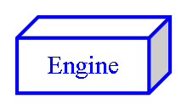 | 1.5 liter Gasoline Engine | 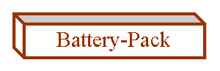 | 201.6 volt NiMH Battery-Pack
 | Vehicle’s Front Wheels |  | PSD (Power-Split-Device)
 | 10 kW Electric Motor/Generator |  | 50 kW Electric Motor/Generator

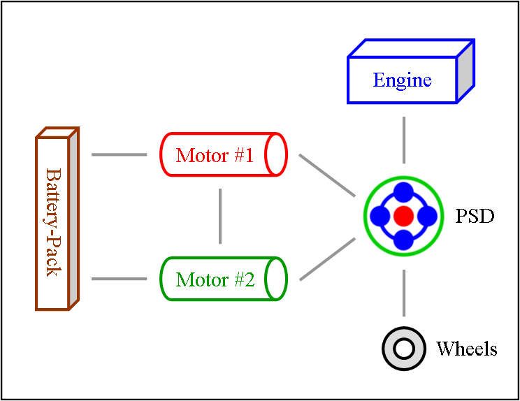 | Stand-By or Gliding  This is the state of the system at rest but still on. You’ll see it when power to the wheels isn’t needed; that’s both when the vehicle is stopped and when it is gliding. The engine may be idling or off.
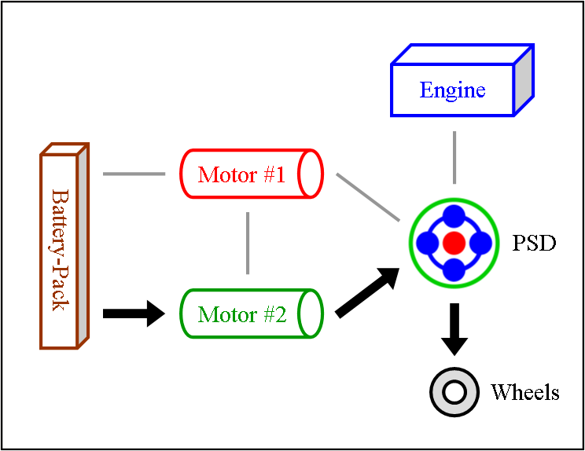 | Stealth or Electric-Only or Reverse  When power to the wheels is supplied entirely by the large motor using only the battery-pack, it is called “Electric-Only”. This can occur at any speed. The only requirement is that the use of gas by the engine must cease; however, the motion of the engine may still continue. When engine activity stops entirely, the mode is referred to as “Stealth”. This is an ability that is possible due to the PSD, a special device that “assist” hybrids do not have. Lastly, since there is no transmission or even any gears that shift, this is how reverse is provided. The large motor simply rotates backward.
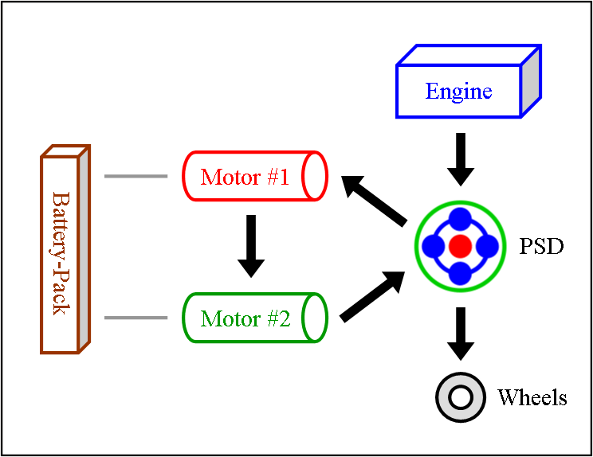 | Engine & Motor Drive  This is when all components of the “full” hybrid system except the battery-pack provide power. The engine spins the PSD, which then distributes 72 % of that thrust to the wheels and 28 % to the small motor. The spinning of the small motor generates electricity, which is immediately used by the large motor to supply additional thrust to the wheels. The benefit of this seemingly cumbersome distribution comes from the engine operating at a very efficient RPM while at the same time allowing the powerful yet efficient motor to contribute thrust. It also ensures longer battery-pack life by simply not using it.
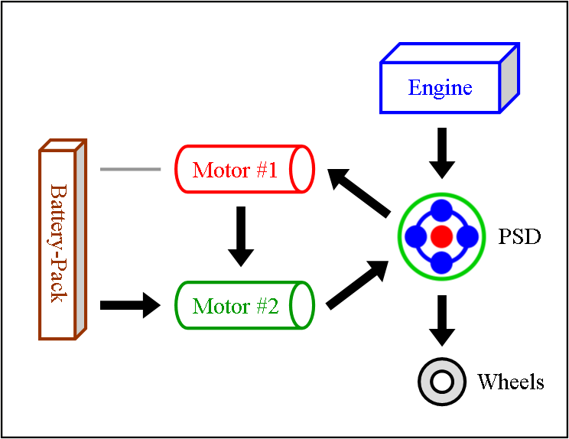 | Full Power or Gradual Slowing  At times when maximum thrust is required, like when merging onto a busy highway, the battery-pack will join in. This additional power is used by the large motor to produce even more thrust to the wheels than is normal needed. The same activity also occurs when slowing down gradually, allowing the engine to significantly reduce gas use without the driver noticing a power distribution change.
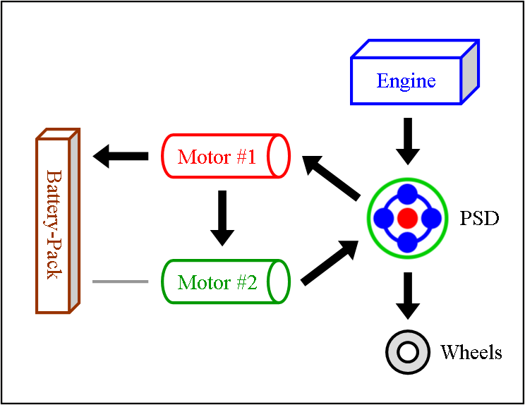 | Engine & Motor Drive + Charge  When the small motor is generating more electricity than what is needed by the large motor at that moment, the surplus is sent to the battery-pack. This is a benefit often overlooked, an efficiency gain due to running the engine at an optimal RPM (which also provides an efficiency gain). This is also the most common method in which hills are climbed, resulting in more stored electricity available at the top than when the climb began.
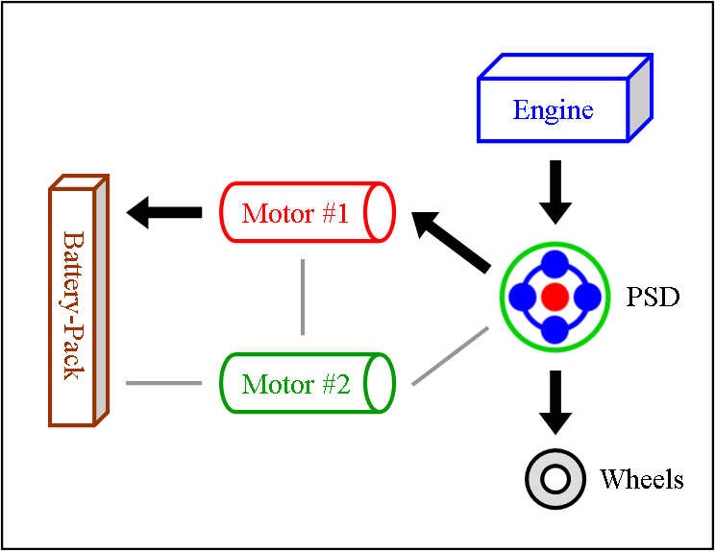 | Engine Drive + Charge  Sometimes the electricity being generated by the small motor isn’t needed. In that case, which happens frequently while cruising on a highway, it is sent to the battery-pack for recharging. Additionally, note that the A/C system is powered only by electricity, meaning it can take advantage of this situation… a design benefit that is often overlooked.
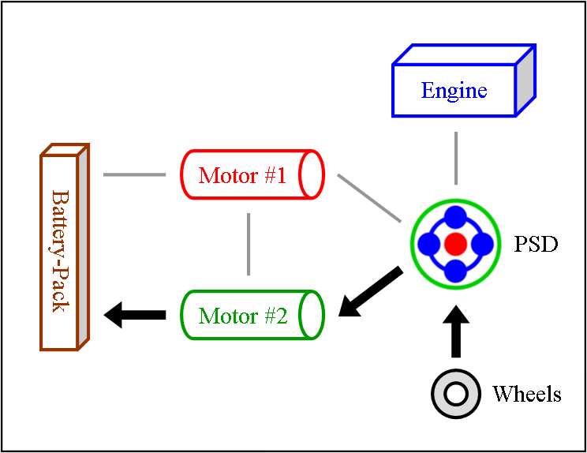 | Regeneration (Braking)  When the driver moderately steps on the brake-pedal, some energy that is normally wasted through friction from brake shoes & pads is instead routed backward through the hybrid system. This causes the large motor to now operate as a generator, which creates electricity to recharge the battery-pack with.  When the driver slams on the brake-pedal to emergency stop, the regeneration cycle is bypassed entirely. All energy is dealt with via the traditional shoe & pad method along with the anti-lock system.
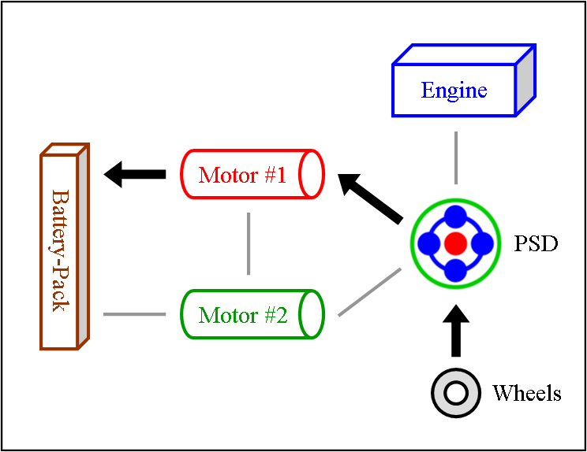 | Regeneration (Excess Capture)  Did you know that the “full” hybrid design provides regeneration electricity even when you don’t step on the brake-pedal? Most have no idea this efficiency gain exists. But it does. It works remarkably well too, and happens far more often than you’d expect. Whenever the vehicle slows down a little bit or it encounters a decline in the road, the small motor works as a generator powered by the wheels rather than the engine to capture that excess energy.
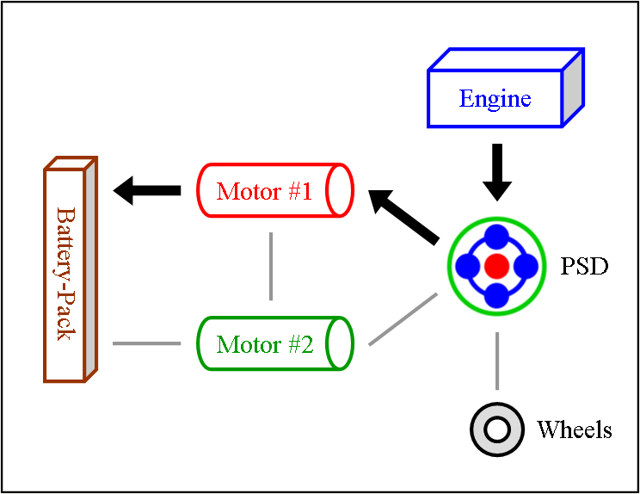 | Engine Heat  When the hybrid system is cold, it will run the engine to create heat for the catalytic-converter. This is required to enable the chemical reaction that cleanses emissions before leaving the tailpipe. Rather than allowing that power from the engine to be wasted while the vehicle is not moving, it is used by the small motor to generate electricity to recharge battery-pack. This same method will also occur when more heat is needed for the heater to keep you warm.

Note #1: The physical layout illustrated for Motor #2 and the PSD has been simplified for easier understanding. The true component connection also includes a “reduction gear” between them. That is actually what supplies the wheels with thrust from the motor; however, all power sent there is equally sent to the PSD. An intriguing benefit resulting from this is ability to rapidly change power distribution modes, enabling remarkably brief opportunities to gain efficiency. This changing occurs so often that it is common to witness it on the Multi-Display 10 to 20 times per minute.

Note #2: The numerical values listed in this document are from the HSD Prius.

