Full Hybrid

1.5 liter Gasoline Engine (57 kW)

201.6 volt Battery-Pack

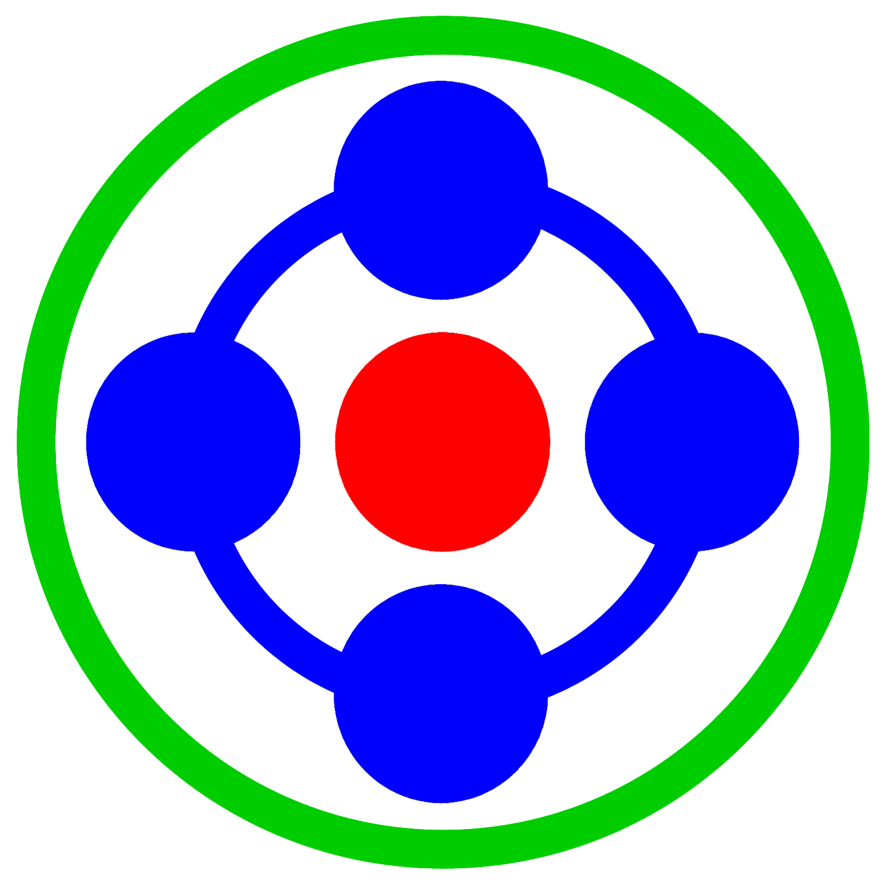
“Full” Hybrids:

● Toyota Prius
● Toyota Camry
● Toyota Highlander
● Lexus RX400h
● Lexus GS450h
● Lexus LS600h
● Ford Escape
● Mercury Mariner
● Nissan Altima

This propulsion system does not resemble a traditional vehicle. There’s no transmission. It’s missing entirely. This design is not an enhancement; instead, it is a complete replacement. The PSD (Power-Split-Device) is used to send power to the wheels. That allows the 2 electric motors/generators and a gasoline engine to interact with each other or operate independently. There are no gears that ever shift, only power carriers to manage the spinning motion of each permanently engaged component.

The engine is run at a RPM optimal for efficiency. 100 percent of the time it is providing power to the wheels, it is also spinning the smaller motor to generate electricity. If extra power for the wheels is needed, that resulting electricity is sent to the larger motor for immediate use. If not, it is sent to the battery-pack to be stored for use later. When only a portion of that electricity is needed, part is used for propulsion and the remainder for recharging. Electricity is also captured when slowly decelerating or stepping on the brakes, transferring motion from the tires for use by either motor for generating. The process of directing electricity flow happens rapidly and often, switching to another after only a few seconds. This design takes advantage of surprisingly brief opportunities to gain efficiency.

Electric-Only operation is also supported. The PSD allows the engine to shut-off completely, enabling the larger motor to send power to the wheels without the engine pistons moving. It is a distinct design feature that provides impressive efficiency in suburb driving and stop & slow commute conditions.
Note: All the values listed in the illustration above are from the HSD Prius.
Wheels
Power-Split-Device

10 kW Electric Motor/Generator
50 kW Electric Motor/Generator

